June Assessment Period 2022-3

Version 3

# PERSON-CENTRED MEDICINE: FROM BENCH TO BEDSIDE EXAM 3

**PHA-6020Y**

# Time allowed: 3 hours

There are **THREE** questions.

You should attempt to answer **ALL THREE** questions and **ALL** parts of each question. Each question has the same value.

Use a **SEPARATE** answer book for **EACH** question. Percentages in square brackets [ ] indicate the marks available for each part of the question.

The paper consists of 20 pages in total.

Each question consists of a patient scenario. For each scenario you should review the information provided before attempting the questions.

# Additional Materials

Students are permitted to access **any** online resources via the provided computer **except** for those that could facilitate communication (including OneDrive and other cloud-based storage/file sharing platforms).

Recommended electronic resources to use are:

* BNF (<https://bnf.nice.org.uk/>)
* Electronic Medicines Compendium ([www.medicines.org.uk](http://www.medicines.org.uk/))
* Medicines Complete ([www.medicinescomplete.com](http://www.medicinescomplete.com/))
* National Institute for Health and Care Excellence (<https://www.nice.org.uk/>)
* PHA-6020Y Blackboard

Students are permitted to take six (6) sides of handwritten notes into the assessment.

# Textbooks are not permitted in this examination. Dictionaries are not permitted in this examination.

**Do not take this question paper out of the examination room.**

# Do not turn over until you are told to do so by the invigilator.

PHA-6020Y Module contact: Emma Marks, PHA Copyright of the University of East Anglia

1. Answer **ALL** parts (a) to (d).

You have a new patient, BL, admitted to the acute medicine ward. Their medical notes, blood test results and drug chart are as follows:

|  |  |  |
| --- | --- | --- |
| **Patient:** | BL | |
| **Hospital number:** | 998076 | |
| **DoB:** | 19.10.1953 | |
| **Gender:** | Female | |
| **Address:** | 82 Windsor Walk, Flatplace | |
|  | | |
| **Day 1:** | Brought in by daughter. | |
| **PC:** | Woke up this morning with lower back and flank pain. Cold and shivery but temperature 39.4. Pain on urination. Urine  dark and foul smelling. Vomited 3 x. Unable to take tablets. | |
| **HPC:** | Patient been feeling under the weather for 2-3 days. Tired, cold and shivery. Reduced oral intake, patient not feeling hungry. Reduced fluid as stinging in urination. | |
| **PMH:** | Rheumatoid arthritis (9 years) – well controlled QRISK3 15 | |
| **DH:** | Methotrexate 2.5 mg tablet - 17.5 mg once a WEEK on a Monday  Atorvastatin 20 mg once a day at night Aspirin 75mg once a day in the morning Folic acid 5mg once a week on a Friday | |
| **Allergies:** | Azathioprine – dizziness, fever, rash, hypotension | |
| **SH:**  **Alcohol**  **Smoking Status Illicit drug use** | 0 - 4 units a week never any more | |
| Nil | |
| Nil | |
| **OE:** | **BP** | 110/67 |
|  | **Temp** | 39.4 C |
|  | **Pulse** | 89 b.p.m |
|  | **Weight** | 72 kg |
|  | **Lungs** | Clear |
|  | **RR** | 19 |
|  | **SpO2** | 98% on air |
|  | Chest clear.  Heart - NAD  Pain on palpation mid abdomen and back  No visible blood in urine but strong and foul smelling No confusion – orientated and alert | |
| *Question 1 continues…* | | |

|  |  |
| --- | --- |
|  |  |
|  |  |
|  |  |
|  |  |

|  |  |
| --- | --- |
| *…question 1 continued.* | |
| **Investigations:** | Bloods – FBC, U&Es, CRP, LFTs and clotting. MSU – cultures and sensitivities |
| **Differential Diagnosis:** | Upper UTI |
| **Plan:** | Paracetamol Antiemetic  Empiric antibiotics as per Trust guidance – IV co-amoxiclav For IV fluids and monitor urine output |
|  | *Dr Williamson* 0990 |
|  | *Nursing notes*  Unable to give oral medication as patient still nauseous and not able to keep tablets down.  Fluids running.  To be discussed with the doctor. Encouraging oral intake.  Nurse *Lily* |

|  |  |
| --- | --- |
| **Day 2** |  |
|  | Microbiology  MSU – organism present *E.Coli*  FBC, LFT and clotting - NAD  Co-amoxiclav R  Ceftriaxone R  Ciprofloxacin S  Gentamicin R  Antibiotic therapy to be reviewed. |
|  | *Dr P Aliyu* (Microbiologist) |
| 10 am | *Nursing notes*  Patient asked for some breakfast. Encouraging oral intake. Has managed a cup of tea.  Nurse *Palker* |

Their blood test results on admission are as follows:

|  |  |  |  |  |
| --- | --- | --- | --- | --- |
| Flatplace Trust | | Consultant/GP: | | PATIENT |
| **PATHOLOGY DEPARTMENT** | | Dr J Williamson | | LOCATION |
| Patient Name: BL | | | NHS No: | Acute |
| 098678543 | medicine |
| Hosp no: | 998076 | Sex: F | Age: 69 years | Pathology |
| Patient Address: 82 Windsor Walk, Flatplace | | | | |
| Lab Episode No: | 774563 |  | Date/Time Collection: Today | |
| Address for Report: Flatplace Hospital, Flatplace | | | | |

|  |  |  |  |  |  |
| --- | --- | --- | --- | --- | --- |
| **BIOCHEMISTRY**  Collection LAB No  Today 774563 |  |  |  |  |  |
|  | **Urea** | **Creatinine** | **Na** | **K** | **eGFR** |
| 7.0 | 84 | 139 | 4.1 | 58.3 |
| (1.7-7.1  mmol/L) | (55-125  mmol/L) | (134-145  mmol/L) | (3.6-5.0  mmol/L) | (ml/min/m2 ) |
|  | **WBC** | **Hb** | **CRP** |  |  |
| **17.2\*** | 123 | **47.0\*** |
| (4-11  x 109/l) | (115 – 164  g/L) | (<10  mg/L) |

*Question 1 continues…*

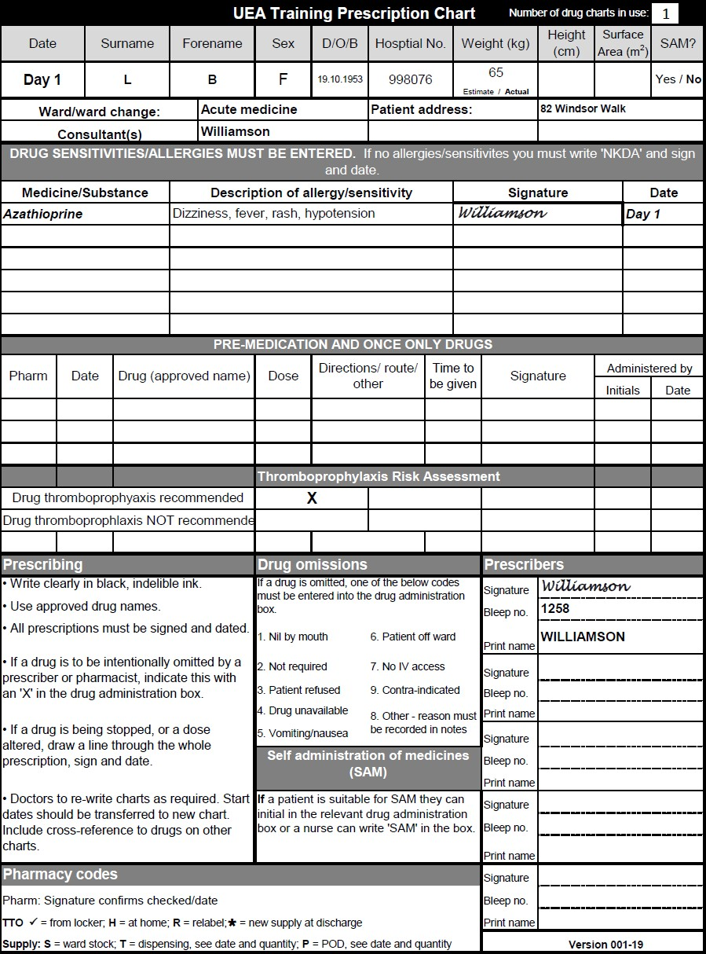

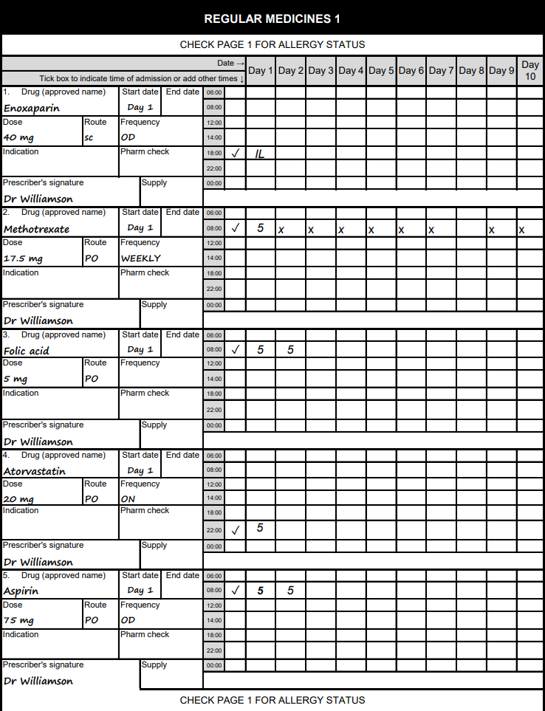

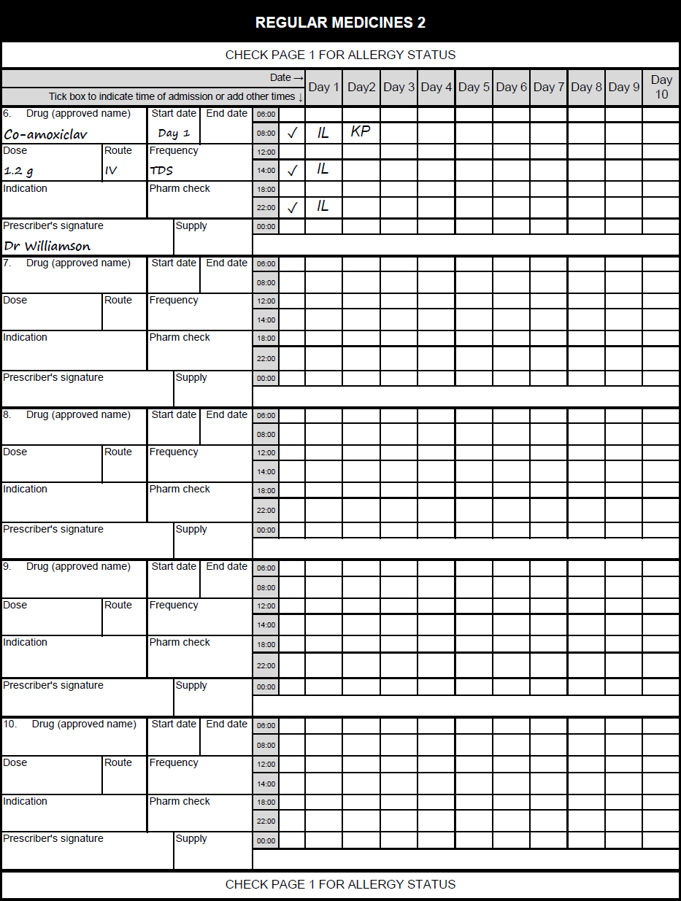

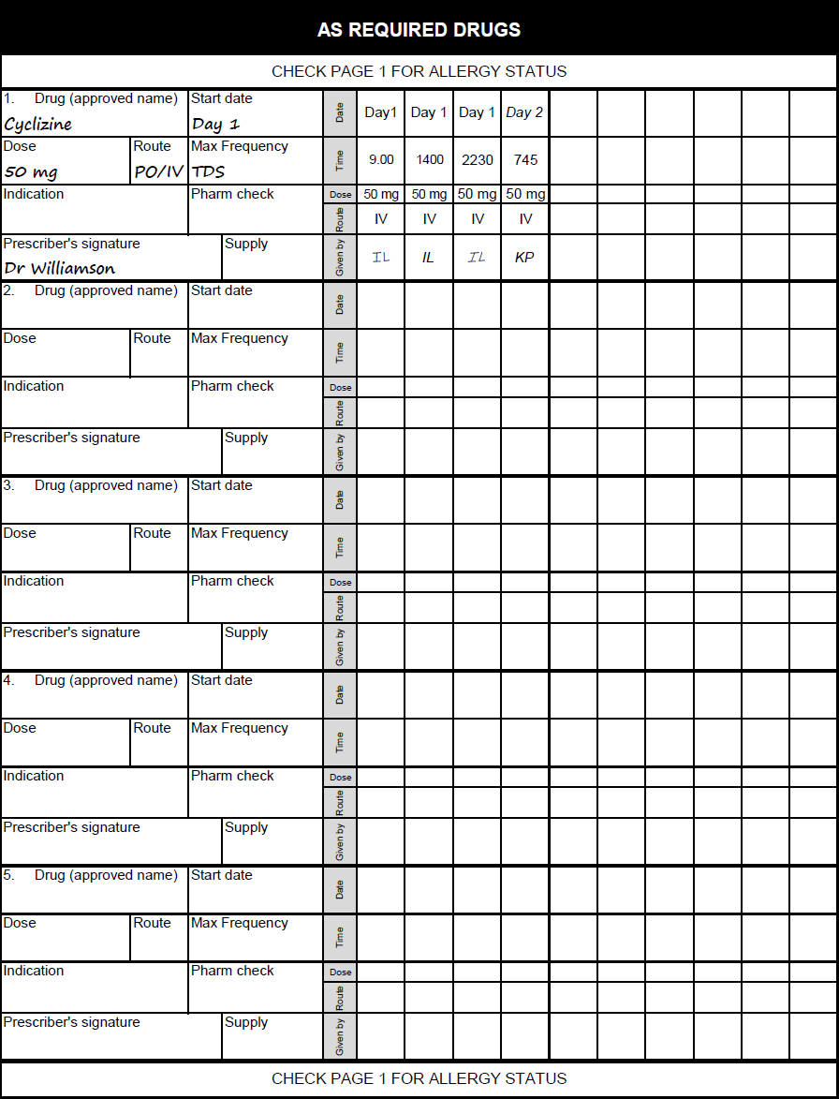

1. For each of the following drugs prescribed for BL (methotrexate, aspirin, atorvastatin and co-amoxiclav), provide details of their indication and therapeutic and toxic monitoring parameters [20%]

### Methotrexate

**Indication:**

* **Rheumatoid Arthritis (RA):** Methotrexate is a disease-modifying antirheumatic drug (DMARD) used to reduce inflammation and slow the progression of RA.

**Therapeutic Monitoring Parameters:**

* **Complete Blood Count (CBC):** Monitor every 2-4 weeks initially, then every 1-3 months once stable, to check for bone marrow suppression (e.g., leukopenia, thrombocytopenia).
* **Liver Function Tests (LFTs):** Monitor every 2-4 weeks initially, then every 1-3 months once stable, to detect hepatotoxicity.
* **Renal Function Tests:** Monitor serum creatinine and estimated glomerular filtration rate (eGFR) periodically due to renal excretion of the drug.
* **Methotrexate Serum Levels:** Occasionally monitored to ensure therapeutic levels, though not routinely required.
* **Chest X-Ray:** Baseline and periodic monitoring to detect potential pulmonary toxicity.

**Toxic Monitoring Parameters:**

* **Signs of Infection:** Due to immunosuppression, patients should be monitored for fever, sore throat, or other signs of infection.
* **Mouth Ulcers and GI Symptoms:** Monitor for oral ulcers, nausea, vomiting, and diarrhea as signs of toxicity.
* **Pulmonary Symptoms:** Watch for dry cough or dyspnea, which may indicate methotrexate-induced pneumonitis.
* **Neurotoxicity:** Rarely, methotrexate can cause neurotoxicity, presenting as headache, dizziness, or cognitive dysfunction.

### Atorvastatin

**Indication:**

* **Hyperlipidemia and Cardiovascular Risk Reduction:** To manage elevated cholesterol levels and reduce the risk of cardiovascular events.

**Therapeutic Monitoring Parameters:**

* **Lipid Profile:** Monitor total cholesterol, LDL-C, HDL-C, and triglycerides at baseline and periodically (every 4-12 weeks initially, then every 3-12 months) to assess efficacy.
* **Liver Function Tests (LFTs):** Monitor baseline LFTs and then periodically (e.g., every 6-12 months) as statins can cause hepatotoxicity.

**Toxic Monitoring Parameters:**

* **Muscle Symptoms:** Monitor for myopathy or rhabdomyolysis. Patients should report muscle pain, tenderness, or weakness.
* **Creatine Kinase (CK):** Measure CK levels if the patient develops muscle symptoms to detect myopathy or rhabdomyolysis.
* **Blood Glucose:** Statins can increase blood glucose levels, so monitor for new-onset diabetes, especially in high-risk patients.

### Co-amoxiclav (Amoxicillin/Clavulanate)

**Indication:**

* **Infection:** Co-amoxiclav is typically prescribed to treat bacterial infections. Specific indications can include respiratory tract infections, urinary tract infections, skin infections, and more.

**Therapeutic Monitoring Parameters:**

* **Symptom Resolution:** Monitor clinical symptoms of infection to assess therapeutic effectiveness.
* **Microbiological Cultures:** Perform cultures to guide antibiotic therapy, especially in cases of resistant infections.

**Toxic Monitoring Parameters:**

* **Liver Function Tests (LFTs):** Monitor periodically, especially in prolonged therapy, to detect hepatotoxicity.
* **Renal Function:** Monitor serum creatinine and eGFR periodically as dose adjustments may be required in renal impairment.
* **Hematologic Monitoring:** CBC to detect potential blood dyscrasias, especially with prolonged use.
* **Signs of Hypersensitivity:** Monitor for allergic reactions such as rash, itching, or anaphylaxis.
* **Gastrointestinal Symptoms:** Watch for diarrhea, nausea, or signs of antibiotic-associated colitis (e.g., Clostridioides difficile infection).

### Summary of Monitoring Plan

For BL, a comprehensive monitoring plan would involve:

* **Methotrexate:** Regular CBC, LFTs, renal function, and clinical monitoring for infection, pulmonary symptoms, and neurotoxicity.
* **Aspirin:** Periodic evaluation of GI symptoms, bleeding risks, platelet function, and renal function.
* **Atorvastatin:** Routine lipid profiles, LFTs, and monitoring for muscle-related side effects and blood glucose levels.
* **Co-amoxiclav:** Monitoring for infection resolution, liver and renal function tests, and watching for hypersensitivity and GI side effects.

1. Critique the patient’s **drug history** in view of their medical history. [25%]

#### Patient's Medical History:

1. **Rheumatoid Arthritis (RA) (9 years) – well controlled**:
   * Chronic inflammatory disorder affecting joints, which can lead to joint damage and systemic complications.
2. **QRISK3 Score: 15**:
   * Indicates a 15% risk of developing cardiovascular disease (CVD) over the next 10 years.
   * This is an intermediate risk and warrants preventive strategies to lower CVD risk.

#### Drug History:

1. **Methotrexate 2.5 mg tablet - 17.5 mg once a week on a Monday**:
   * **Indication**: Methotrexate is a first-line disease-modifying antirheumatic drug (DMARD) used for RA.
   * **Efficacy**: At a dose of 17.5 mg weekly, it is within the commonly used range for RA management, often contributing to well-controlled disease.
   * **Administration**: Weekly dosing is appropriate to minimize toxicity.
   * **Safety**: Monitor liver function tests, renal function, and complete blood count regularly due to potential hepatotoxicity, myelosuppression, and nephrotoxicity.
   * **Drug Interactions**: Avoid concomitant use with NSAIDs or other nephrotoxic agents which can increase methotrexate toxicity.
2. **Atorvastatin 20 mg once a day at night**:
   * **Indication**: Statins are indicated for primary prevention of CVD in patients with an intermediate QRISK3 score.
   * **Efficacy**: Atorvastatin 20 mg is a moderate-intensity statin, expected to reduce LDL cholesterol by 30-50%.
   * **Administration**: Night-time dosing is recommended for statins due to the diurnal rhythm of cholesterol synthesis.
   * **Safety**: Monitor liver function tests and creatine kinase levels, particularly if the patient experiences myalgia or other muscle-related symptoms.
   * **Drug Interactions**: Caution with drugs that are CYP3A4 inhibitors which can increase atorvastatin levels and the risk of myopathy.

• **Aspirin 75 mg once a day in the morning**:

* **Indication**: Low-dose aspirin is used for its antiplatelet effects, beneficial in CVD prevention.
* **Efficacy**: Provides a reduction in thrombotic events, appropriate for a patient with a QRISK3 score of 15.
* **Safety**: Regular monitoring for gastrointestinal bleeding and peptic ulcer disease, particularly given the patient's age and chronic use.
* **Drug Interactions**: Increased risk of bleeding with concurrent use of other antiplatelets, anticoagulants, or NSAIDs.

• **Folic acid 5 mg once a week on a Friday**:

* **Indication**: Folic acid is used to mitigate methotrexate-induced folate deficiency and associated side effects such as gastrointestinal intolerance, hepatotoxicity, and hematologic toxicity.
* **Efficacy**: Weekly dosing is a common practice, though some regimens may use daily lower doses.
* **Administration**: Separate day from methotrexate administration to avoid interference with methotrexate efficacy.
* **Safety**: Folic acid supplementation generally has a good safety profile with minimal side effects.

### Overall Critique and Recommendations:

1. **Methotrexate and Folic Acid**:
   * The regimen of methotrexate 17.5 mg weekly is appropriate for RA and aligns with guidelines for dosing and monitoring.
   * Folic acid 5 mg weekly is adequate for preventing methotrexate toxicity but consider if folic acid 1 mg daily (except the day of methotrexate) might offer better side effect mitigation.
2. **Cardiovascular Risk Management**:
   * Atorvastatin 20 mg nightly is suitable for an intermediate-risk patient, supporting lipid management and CVD prevention.
   * Aspirin 75 mg daily is appropriate for primary prevention given the QRISK3 score.
3. **Monitoring and Follow-up**:
   * Regular monitoring of liver function, renal function, and complete blood counts due to methotrexate use.
   * Periodic review of lipid profile and liver function tests for atorvastatin.
   * Surveillance for gastrointestinal side effects from aspirin.
4. **Potential Drug Interactions and Adverse Effects**:
   * Careful monitoring for signs of myopathy due to potential atorvastatin-methotrexate interaction.
   * Vigilance for gastrointestinal symptoms and bleeding risks associated with chronic aspirin use.
5. **Patient Education**:
   * Ensure the patient understands the importance of adherence to the prescribed regimen, particularly the weekly dosing schedule of methotrexate and folic acid.
   * Educate on recognizing and reporting signs of potential adverse effects, such as unusual bruising, muscle pain, or gastrointestinal discomfort.

In conclusion, the patient's drug history is appropriate and well-aligned with their medical history, focusing on effective RA management and cardiovascular risk reduction. Regular monitoring and patient education are crucial to optimize therapeutic outcomes and minimize potential risks.

Critique the patient’s **acute treatmen**t during admission. For any pharmaceutical care issues identified describe the action you would like to take to resolve these. [30%]

**Presentation:**

* BL presented with symptoms suggestive of an upper urinary tract infection (UTI) including lower back and flank pain, fever (39.4°C), dysuria, dark and foul-smelling urine, and vomiting.
* PMH includes well-controlled rheumatoid arthritis managed with methotrexate.
* Examination findings indicated a high fever, pain on abdominal and back palpation, and clear lungs and heart sounds.

**Initial Management:**

* The treatment plan included paracetamol for fever, antiemetic (cyclizine) for nausea, and empiric IV antibiotics (co-amoxiclav) according to Trust guidelines.
* IV fluids were started to maintain hydration, and oral intake was encouraged.

#### Issues Identified:

1. **Empiric Antibiotic Choice:**
   * **Issue:** Co-amoxiclav was selected as empiric therapy. However, the patient's specific bacterial susceptibility results (Day 2) showed resistance (R) to co-amoxiclav.
   * **Action:** Review the choice of empiric antibiotics immediately. Switch to an antibiotic to which the organism (E. coli) is sensitive. In this case, ciprofloxacin, which showed sensitivity (S), should be initiated.
2. **Microbiological Confirmation and Sensitivity:**
   * **Issue:** The MSU culture confirmed E. coli, and sensitivity results were available on Day 2.
   * **Action:** Immediate adjustment of the antibiotic regimen based on the microbiology results is critical. The IV co-amoxiclav should be discontinued and replaced with ciprofloxacin, given the sensitivities.
3. **Nausea and Vomiting Management:**
   * **Issue:** BL was unable to tolerate oral medication initially due to nausea and vomiting.
   * **Action:** Continue antiemetic therapy with cyclizine IV if PO(oral) is not tolerated. Reassess regularly to switch to oral as soon as feasible. Monitor for effectiveness and side effects.
4. **Hydration Status:**
   * **Issue:** Reduced oral intake and vomiting necessitated IV fluid administration.
   * **Action:** Ensure IV fluids are appropriately managed to avoid dehydration and monitor urine output closely. Adjust the fluid rate based on clinical response and laboratory results.
5. **Methotrexate Management:**
   * **Issue:** Methotrexate, used for rheumatoid arthritis, can cause immunosuppression, complicating infections.
   * **Action:** Temporarily hold methotrexate until the infection is under control. Coordinate with the rheumatology team for further management and restarting methotrexate. Monitor for signs of infection exacerbation.
6. **Pain Management:**
   * **Issue:** The patient reported significant pain which can hinder recovery.
   * **Action:** Adequately manage pain with paracetamol and consider adding opioids if necessary, given the renal function allows. Monitor for side effects and efficacy.
7. **Anticoagulation:**
   * **Issue:** Enoxaparin 40mg SC once daily was initiated for thromboprophylaxis.
   * **Action:** Continue enoxaparin but assess bleeding risk given the patient’s infection and inflammatory status. Monitor for signs of bleeding and adjust dose if necessary.
8. **Regular Monitoring:**
   * **Issue:** The patient’s renal function showed a slightly reduced eGFR (58.3 ml/min/m2).
   * **Action:** Monitor renal function daily, especially due to the nephrotoxicity potential of some antibiotics (e.g., gentamicin). Adjust doses of renally excreted drugs accordingly.

### Summary of Recommended Actions:

1. **Switch empiric antibiotic therapy** from IV co-amoxiclav to IV ciprofloxacin based on sensitivity results.
2. **Maintain antiemetic therapy** with cyclizine IV, transitioning to oral as tolerated.
3. **Continue IV fluids** and closely monitor fluid balance and renal function.
4. **Temporarily hold methotrexate** and consult with the rheumatology team for further management.
5. **Provide adequate pain relief** with paracetamol and consider additional analgesics if needed.
6. **Continue enoxaparin** for thromboprophylaxis with regular monitoring for bleeding risk.
7. **Daily monitoring of renal function** and adjust medication doses as required.

Ciprofloxacin therapeutic and toxic monitoring parameters:

**Therapeutic monitoring parameters**

1. **Infection Resolution**:
   * **Clinical Signs and Symptoms**: Improvement in fever, reduction in white blood cell count, and resolution of specific signs of infection (e.g., improved breathing in pneumonia, less pain in urinary tract infections).
   * **Microbiological Eradication**: Follow-up cultures to ensure the pathogen is eradicated.
2. **Dosing and Administration**:
   * **Adherence to Dosing Schedule**: Ensure the patient takes the medication as prescribed, typically 250-750 mg every 12 hours depending on the infection severity.
   * **Renal Function**: Ciprofloxacin is primarily excreted by the kidneys. Adjust dose based on creatinine clearance (CrCl):
     + CrCl > 50 mL/min: Standard dosing.
     + CrCl 30-50 mL/min: 250-500 mg every 12 hours.
     + CrCl < 30 mL/min: 250-500 mg every 18-24 hours.
3. **Drug Interactions**:
   * **Monitoring for Interactions**: Ciprofloxacin can interact with various drugs (e.g., theophylline, warfarin) and may require dose adjustments or increased monitoring of co-administered drugs.

**Toxic Monitoring Parameters**

1. **Gastrointestinal Effects**:
   * **Symptoms**: Nausea, vomiting, diarrhea, and abdominal pain.
   * **Management**: Symptomatic treatment or discontinuation if severe.
2. **Tendinopathy and Tendon Rupture**:
   * **Risk Factors**: Age > 60, concurrent corticosteroid use, renal impairment, and history of tendon disorders.
   * **Monitoring**: Patient education to report tendon pain, swelling, or inflammation. Discontinue at the first sign of tendon pain or inflammation.
3. **Central Nervous System Effects**:
   * **Symptoms**: Headache, dizziness, confusion, tremors, hallucinations, and seizures.
   * **Monitoring**: Particularly important in the elderly or those with CNS disorders. Reduce dose or discontinue if severe CNS effects occur.
4. **QT Prolongation**:
   * **Risk Factors**: Co-administration with other QT-prolonging drugs, existing QT prolongation, electrolyte disturbances.
   * **Monitoring**: Baseline and periodic ECG in patients at risk. Discontinue if significant QT prolongation occurs.
5. **Hypersensitivity Reactions**:
   * **Symptoms**: Rash, pruritus, anaphylaxis.
   * **Monitoring**: Educate patient on signs of allergic reactions and advise immediate discontinuation and medical attention if they occur.
6. **Hepatotoxicity**:
   * **Monitoring**: Liver function tests (LFTs) before starting therapy and periodically during treatment, especially in patients with preexisting liver disease.
7. **Blood Glucose Disturbances**:
   * **Symptoms**: Hypoglycemia or hyperglycemia.
   * **Monitoring**: Blood glucose levels in diabetic patients or those on hypoglycemic agents.

5 months after discharge, BL attends a rheumatology outpatient clinic appointment for a review of her methotrexate treatment. Her blood test results are as follows:

|  |  |  |  |  |
| --- | --- | --- | --- | --- |
| Flatplace Trust  **PATHOLOGY DEPARTMENT** | | Consultant/GP: Dr York | | PATIENT LOCATION |
| Patient Name: BL | | | NHS No:  098678543 | Acute  medicine |
| Hosp no: | 998076 | Sex: F | Age: 69 years | Pathology |
| Patient Address: 82 Windsor Walk, Flatplace | | | | |
| Lab Episode No: | 000987 |  | Date/Time Collection: yesterday | |
| Address for Report: Flatplace Hospital, Flatplace | | | | |

|  |  |  |  |  |  |
| --- | --- | --- | --- | --- | --- |
| **BIOCHEMISTRY**  Collection LAB No  Today 000987 |  |  |  |  |  |
|  | **Urea** | **Creatinine** | **eGFR** | **LFT** |  |
| 6.1 | 67 | 75 | NAD |
| (1.7-7.1  mmol/L) | (55-125  mmol/L) | (ml/min/m2 ) |  |
|  | **WBC** | **Hb** | **CRP** | **ESR** |  |
| **17.2\*** | 120 | **58.0\*** | **65\*** |
| (4-11  x 109/L ) | (115 – 164  g/L) | (<10  mg/L) | (1-15  mm/hr) |

BL reports an increase in her morning stiffness with pain, erythema, and swelling of both hands. This has led to reduction in her ability to undertake her daily tasks such as brushing her teeth, fastening buttons, and writing the shopping list. Her symptoms have also started to occur in her wrists. Her DAS28 score is 4.8 this visit.

The rheumatologist increases the patient’s dose of methotrexate to 20 mg ONCE a week, organises a follow-up appointment 6-8 weeks, with weekly drug monitoring with their GP.

At the follow-up appointment, the DAS28 has reduced to 4.6, however there is little noticeable symptom improvement. The rheumatologist starts sulfasalazine 500 mg OD to be gradually increased.

1. Critique the long-term management of BL’s rheumatoid arthritis. For any pharmaceutical care issues identified describe the action you would like to take to resolve these. [25%]

**Critique of Long-Term Management of BL’s Rheumatoid Arthritis**

### Patient Background:

* **Age:** 69 years
* **Sex:** Female
* **Condition:** Rheumatoid Arthritis (RA)
* **Current Medication:** Methotrexate 20 mg once weekly

### Pathology Results Analysis:

1. **Blood Test Results:**
   * **WBC:** 17.2 x 10^9/L (High)
   * **Hb:** 120 g/L (Normal but on the lower side)
   * **CRP:** 58.0 mg/L (Elevated)
   * **ESR:** 65 mm/hr (Elevated)
   * **Urea:** 6.1 mmol/L (Normal)
   * **Creatinine:** 67 mmol/L (Normal)
   * **eGFR:** 75 ml/min/m2 (Normal)
   * **LFT:** No abnormalities detected
2. **Clinical Presentation:**
   * Increase in morning stiffness, pain, erythema, and swelling in both hands and wrists
   * Reduced ability to perform daily tasks
   * DAS28 score of 4.8 (moderate to high disease activity)
3. **Response to Treatment:**
   * Increased methotrexate to 20 mg once weekly
   * Follow-up after 6-8 weeks showed a DAS28 of 4.6 with little noticeable symptom improvement
   * Addition of sulfasalazine 500 mg OD, to be gradually increased

### Identified Pharmaceutical Care Issues:

1. **Inadequate Control of RA Symptoms:**
   * Persistent high DAS28 score despite increased methotrexate dose
   * Continued high levels of inflammatory markers (CRP, ESR)
   * Patient experiencing significant morning stiffness and functional impairment
2. **Potential Methotrexate Toxicity:**
   * Elevated WBC count (leukocytosis), possibly indicating an infection or inflammation
   * Need for monitoring of methotrexate side effects (e.g., hepatotoxicity, myelosuppression)
3. **Suboptimal Response to Methotrexate:**
   * Despite dose escalation, minimal symptom improvement
   * May indicate inadequate response to methotrexate monotherapy

### Recommended Actions:

1. **Review and Optimize Anti-Rheumatic Therapy:**
   * **Assessment of Methotrexate Efficacy and Toxicity:**
     + Conduct thorough assessment to rule out methotrexate toxicity (e.g., liver function tests, renal function, complete blood count)
     + Consider switching from oral to subcutaneous methotrexate for better bioavailability and reduced gastrointestinal side effects
   * **Addition of DMARDs:**
     + Continue with the initiation of sulfasalazine, titrating to the target dose while monitoring for side effects (e.g., gastrointestinal disturbances, rash, liver function abnormalities)
     + Consider adding a biologic DMARD (e.g., TNF inhibitors, IL-6 inhibitors) if the combination of methotrexate and sulfasalazine fails to control disease activity adequately
2. **Address Elevated Inflammatory Markers:**
   * Investigate potential sources of infection or inflammation contributing to leukocytosis and elevated CRP/ESR
   * Ensure appropriate treatment if an infection is identified

**Symptom Management:**

* + **Pain and Stiffness Relief:**
    - Short-term use of NSAIDs or corticosteroids to manage acute flare-ups and reduce inflammation and pain- NSAIDS and methotrexate is important to be used with caution and must be approved by the rheumatologist before being administered. Important to tell the patient to report signs of methotrexate toxicity such as sore throat, mouth ulcers, unexplained bleeding or bruising.
    - Consider physical therapy to maintain joint function and improve mobility
  + **Functional Support:**
    - Occupational therapy referral to assist with daily tasks and recommend assistive devices as needed

**Patient Education and Monitoring:**

* + Educate BL on the importance of medication adherence and potential side effects
  + Schedule regular follow-up appointments to monitor disease progression, treatment efficacy, and adverse effects
  + Emphasize the need for routine blood tests to monitor methotrexate and sulfasalazine therapy

**Comprehensive Review of Co-Morbid Conditions:**

* + Given BL's age, evaluate for co-morbid conditions (e.g., cardiovascular risk factors, osteoporosis) and manage accordingly
  + Ensure vaccination status is up to date to prevent infections, especially with immunosuppressive therapy

### Conclusion:

The current management of BL’s rheumatoid arthritis shows some gaps in achieving optimal disease control. The recommendations above focus on intensifying therapy with additional DMARDs, monitoring for toxicity, addressing elevated inflammatory markers, and supporting symptom relief and functional improvement. Regular follow-up and patient education are crucial in ensuring long-term management success.

Answer **ALL** parts (a) to (f).

You have a new patient, CJ, admitted to the cardiology ward. Their medical notes, blood test results and drug chart are as follows:

|  |  |  |
| --- | --- | --- |
| **Patient:** | CJ |  |
| **Hospital number:** | 032789 |  |
| **DoB:** | 01.03.1948 |  |
| **Gender:** | M |  |
| **Address:** | 24 St James’ Road, Flatplace | |
| **PC:** | Severe shortness of breath | |
| **HPC:** | Over past week has become increasingly SOB whilst mobilising. Now needing 3 pillows at night to sleep and SOB at rest. Also complaining of cough with green sputum | |
| **PMH:** | Type 2 DM (20 years)  Hypertension (15 years) | |
| **Allergies:** | Penicillin => rash | |
| **DH:** | Amlodipine 10mg od Ramipril 5mg od Pravastatin 40mg on Metformin MR 1g bd Linagliptin 5mg od | |
| **SH:** | Retired bank manager | |
| **Alcohol** | 10-15 units/week | |
| **Smoking Status** | Smoker – 10-15 roll-ups/day | |
| **OE** | Patient short of breath, struggling to speak | |
|  | BP | 150/95 |
|  | Temp | 38.8oC |
|  | Pulse | 95bpm (regular) |
|  | Weight  Lungs   | 83kg (increased in last few weeks – normally 75Kg)  Bibasal crackles ++++ |
| **Investigations:** | Chest X-ray – pulmonary oedema + consolidation Echo- EF 38% | |
| **Diagnosis:** | Acute LVF + chest infection | |
| **Plan:** | IV diuretics and antibiotics  ***Dr Patel* Bleep 561** | |

*Question 2 continues…*

Their blood test results on admission are as follows:

|  |  |  |  |  |
| --- | --- | --- | --- | --- |
| Norfolk and Norwich University Hospital NHS Trust **PATHOLOGY DEPARTMENT** | | Consultant/GP: Dr J Patel | | PATIENT LOCATION  ***Cardiac Ward*** |
| Patient Name: CJ | | | NHS No: 34560978 |
| Hosp no: | 032789 | Sex: M | Age: 75 Yr | Pathology |
| Patient Address: 24 St James’ Road, Flatplace | | | | |
| Lab Episode No: | 15458 |  | Date/Time Collection: Today | |
| Address for Report: Flatplace Hospital, Flatplace | | | | |

|  |  |  |  |  |  |
| --- | --- | --- | --- | --- | --- |
| **BIOCHEMISTRY**  Collection LAB No Today 15458 |  |  |  |  |  |
|  | **Urea**  6.9  (1.7-7.1)  mmol/L | **Creatinine**  122  (55-125)  µmol/L | **Na**  138  (134-145)  mmol/L | **K**  4.1  (3.6-5.0)  mmol/L | **eGFR**  79  ml/min/m2 |
|  | **HbA1c**  59  mmol/mol | **Random blood glucose**  8.2  mmol/L | **WBC**  **17.2\***  (4-11)  x 109/l |  |  |

*Question 2 continues…*

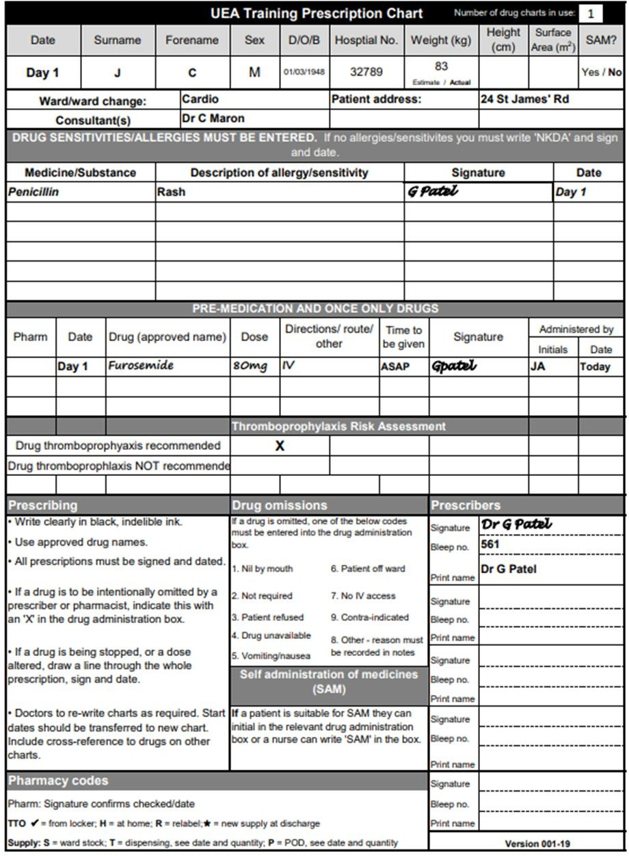

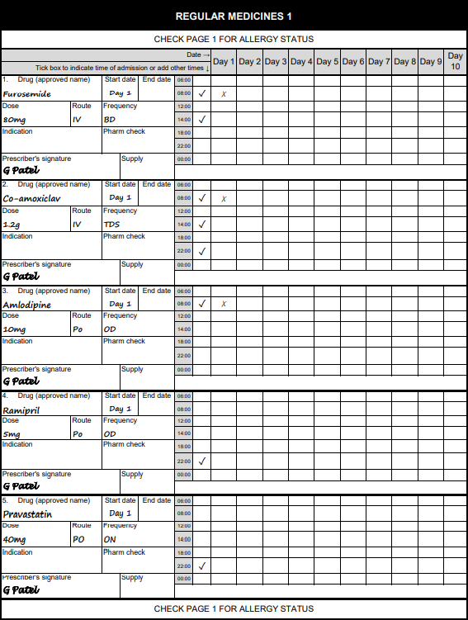

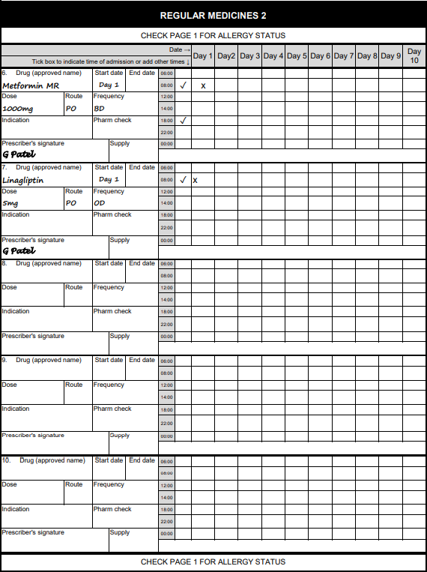

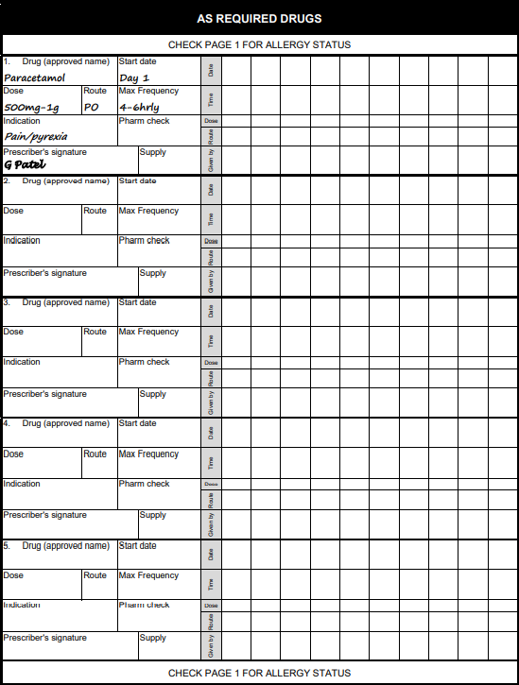

1. For each of the drugs prescribed for CJ (furosemide, co-amoxiclav, amlodipine, ramipril, pravastatin, metformin and linagliptin), provide details of their indication and therapeutic and toxic monitoring parameters. [20%]

#### **Furosemide**

* **Indication**: Furosemide is prescribed for acute left ventricular failure (LVF) and pulmonary edema. It is a loop diuretic used to relieve symptoms by promoting diuresis and reducing fluid overload.
* **Therapeutic Monitoring**:
  + **Effectiveness**: Monitor urine output, weight, and improvement in symptoms of pulmonary congestion (shortness of breath, edema).
  + **Blood Pressure**: Monitor BP to avoid hypotension.
  + **Renal Function**: Regular monitoring of serum creatinine and eGFR.
  + **Electrolytes**: Monitor serum potassium, sodium, and magnesium levels regularly.
* **Toxic Monitoring**:
  + **Ototoxicity**: Monitor for signs of hearing loss or tinnitus.
  + **Dehydration and Electrolyte Imbalance**: Watch for symptoms like dry mouth, confusion, muscle cramps, or arrhythmias.

#### **Co-amoxiclav (Amoxicillin/Clavulanic Acid)**

* **Indication**: Prescribed for chest infection, particularly considering penicillin allergy was likely ruled out for severe infections requiring broader coverage.
* **Therapeutic Monitoring**:
  + **Infection Resolution**: Monitor clinical signs of infection resolution (reduced fever, improved cough, reduced sputum production).
  + **C-Reactive Protein (CRP)**: Monitor CRP levels to assess response to therapy.
  + **WBC Count**: Follow-up WBC count to ensure it returns to normal range.
* **Toxic Monitoring**:
  + **Liver Function Tests (LFTs)**: Monitor liver enzymes for signs of hepatotoxicity.
  + **Renal Function**: Given the renal excretion, monitor kidney function to avoid accumulation.
  + **Allergic Reactions**: Watch for signs of allergic reactions, despite initial negative history.

#### **Amlodipine**

* **Indication**: Amlodipine is used for hypertension and angina. It is a calcium channel blocker.
* **Therapeutic Monitoring**:
  + **Blood Pressure**: Regular monitoring to ensure target BP is achieved and maintained.
  + **Angina Symptoms**: Monitor for frequency and severity of angina attacks.
* **Toxic Monitoring**:
  + **Peripheral Edema**: Watch for development or worsening of peripheral edema.
  + **Heart Rate**: Monitor for reflex tachycardia or bradycardia.
  + **Liver Function**: Periodic LFTs, especially if liver dysfunction is suspected.

#### **Ramipril**

* **Indication**: Ramipril is an ACE inhibitor used for hypertension and heart failure management.
* **Therapeutic Monitoring**:
  + **Blood Pressure**: Regular monitoring to maintain target BP.
  + **Heart Failure Symptoms**: Monitor for improvement in symptoms like shortness of breath and edema.
* **Toxic Monitoring**:
  + **Renal Function**: Regular serum creatinine and eGFR assessments.
  + **Electrolytes**: Monitor serum potassium for hyperkalemia.
  + **Cough**: Monitor for persistent dry cough, a common side effect.
  + **Angioedema**: Watch for signs of angioedema (swelling of face, lips, or throat).

#### **Pravastatin**

* **Indication**: Pravastatin is prescribed for hyperlipidemia to reduce cardiovascular risk.
* **Therapeutic Monitoring**:
  + **Lipid Profile**: Monitor LDL, HDL, total cholesterol, and triglycerides periodically.
  + **Cardiovascular Symptoms**: Monitor for reduction in cardiovascular events and symptoms.
* **Toxic Monitoring**:
  + **Liver Function**: Regular LFTs to monitor for hepatotoxicity.
  + **Muscle Symptoms**: Monitor for myopathy or rhabdomyolysis symptoms (muscle pain, weakness, dark urine).

#### **Metformin**

* **Indication**: Metformin is used for managing type 2 diabetes mellitus (T2DM).
* **Therapeutic Monitoring**:
  + **Blood Glucose Levels**: Monitor fasting blood glucose and HbA1c to assess glycemic control.
  + **Renal Function**: Regular monitoring of serum creatinine and eGFR.
* **Toxic Monitoring**:
  + **Lactic Acidosis**: Monitor for signs of lactic acidosis (malaise, myalgia, respiratory distress).
  + **GI Tolerability**: Watch for gastrointestinal side effects like nausea and diarrhea.

#### **Linagliptin**

* **Indication**: Linagliptin is used for type 2 diabetes mellitus as a DPP-4 inhibitor to improve glycemic control.
* **Therapeutic Monitoring**:
  + **Blood Glucose Levels**: Monitor fasting blood glucose and HbA1c.
* **Toxic Monitoring**:
  + **Pancreatitis**: Monitor for symptoms of pancreatitis (severe abdominal pain, nausea, vomiting).
  + **Hypersensitivity Reactions**: Watch for allergic reactions, including angioedema and severe skin reactions.

Critique the patient’s chest infection management during admission. For any pharmaceutical care issues identified describe the action you would take to resolve these. Include in your answer any monitoring parameters for new medication where appropriate. [10%]

• The patient has a documented penicillin allergy (rash), yet no specific antibiotic regimen is detailed in the notes. It's critical to ensure that the chosen antibiotic avoids cross-reactivity and is effective against the likely pathogens causing the chest infection, given the presence of green sputum indicating a bacterial infection.

• **Action:** Recommend an antibiotic from a different class. For a patient with a penicillin allergy, give clarithromycin, for a patient without penicillin allergy give amoxicillin. A sputum culture and sensitivity test should also be conducted to tailor the antibiotic therapy appropriately.

• Smoking contributes to both respiratory infections and cardiovascular disease progression.

• **Action:** Provide smoking cessation support, including counseling and pharmacotherapy (e.g., nicotine replacement therapy or varenicline). Address this during the hospital stay and ensure follow-up support post-discharge.

Check handwritten notes for therapeutic and toxic monitoring parameters for the antibiotics

1. Critique the patient’s heart failure management during admission. For any pharmaceutical care issues identified describe the action you would take to resolve these. Your answer should include the management of both acute and chronic heart failure. Include in your answer any monitoring parameters for new medication where appropriate. [30%]

Therapeutic monitoring parameters- Symptoms of heart failure (e.g. SOB), weight (aim 1kg/day loss), urine output (aim negative fluid balance)

Toxic monitoring parameters- BP, pulse, initial worsening of symptoms of heart failure

#### **Acute Management of Heart Failure (HF)**

1. **IV Diuretics**
   * **Current Management:** Administration of intravenous diuretics is appropriate for acute left ventricular failure (LVF) presenting with severe shortness of breath and pulmonary edema.
   * **Pharmaceutical Care Issue:** Monitor for electrolyte imbalances (hypokalemia, hyponatremia) and renal function (risk of diuretic-induced nephrotoxicity).
   * **Action:** Regularly monitor serum electrolytes (Na, K) and renal function (serum creatinine, urea). Adjust diuretic dose based on patient's response and laboratory results. Consider potassium supplements or a potassium-sparing diuretic if hypokalemia develops.
2. **Antibiotics for Chest Infection**
   * **Current Management:** Co-amoxiclav (amoxicillin/clavulanic acid) is prescribed, but the patient has a penicillin allergy.
   * **Pharmaceutical Care Issue:** Risk of allergic reaction to penicillin derivatives.
   * **Action:** Discontinue co-amoxiclav. Substitute with an appropriate antibiotic such as doxycycline or a macrolide (e.g., azithromycin), considering local resistance patterns and patient's renal function.
3. **Management of Acute HF Symptoms**
   * **Current Management:** Symptomatic management includes addressing the acute exacerbation of heart failure.
   * **Pharmaceutical Care Issue:** Potential underuse of other supportive measures (e.g., oxygen therapy, non-invasive ventilation if indicated).
   * **Action:** Assess need for supplemental oxygen or non-invasive ventilation. Initiate if hypoxemia or respiratory distress is present. Continuous monitoring of oxygen saturation and respiratory rate is necessary.

#### **Chronic Heart Failure Management**

1. **Heart Failure with Reduced Ejection Fraction (HFrEF) Management**
   * **Current Management:** Patient is on Ramipril (ACE inhibitor) and Amlodipine (calcium channel blocker).
   * **Pharmaceutical Care Issue:** Absence of beta-blocker and mineralocorticoid receptor antagonist (MRA) in the regimen.
   * **Action:** Initiate a beta-blocker (e.g., bisoprolol or carvedilol) and an MRA (e.g., spironolactone or eplerenone) once the patient is hemodynamically stable. These are essential components of HFrEF management to improve survival and reduce hospitalizations. Monitor blood pressure, heart rate, renal function, and serum potassium.

• **Beta-blockers**

* **Parameters:** Heart rate, blood pressure, signs of worsening heart failure (e.g., increased shortness of breath, edema), and patient tolerance.
* **Frequency:** Baseline, then regularly (e.g., weekly during titration).

• **Mineralocorticoid Receptor Antagonists (MRAs)**

* **Parameters:** Serum potassium, renal function (serum creatinine, eGFR), blood pressure.
* **Frequency:** Baseline, 1 week after initiation, monthly for the first 3 months, and then every 3 months.

• **SGLT2 Inhibitors**

* **Parameters:** Blood glucose, HbA1c, renal function, signs of urinary tract infections or genital infections.
* **Frequency:** Baseline, then every 3-6 months.

Why should dalteparin be stopped before DOAC is administered in a patient who has Atrial fibrillation and therefore has an increase risk of stroke?

### **Avoidance of Overlapping Anticoagulation**

**Mechanism of Action:**

* **Dalteparin:** A low molecular weight heparin (LMWH) that works by potentiating the activity of antithrombin III, inhibiting factors Xa and IIa (thrombin).
* **DOACs:** Directly inhibit specific clotting factors (e.g., factor Xa or thrombin), providing anticoagulation without the need for antithrombin.

**Risk of Overlapping:**

* If both dalteparin and a DOAC are administered simultaneously, it can lead to excessive anticoagulation. This significantly increases the risk of bleeding complications, which can be particularly hazardous in an acutely ill patient.

**Timing of Transition:**

* It is essential to allow the effect of dalteparin to diminish before starting a DOAC to ensure that the patient is not exposed to dual anticoagulant effects, which would elevate bleeding risk.

### **Clinical Guidelines and Best Practices**

**Guideline Recommendations:**

* Clinical guidelines recommend transitioning from parenteral anticoagulants (like dalteparin) to oral anticoagulants (like DOACs) with careful timing to balance the risks of thrombosis and bleeding.
* The usual practice involves stopping dalteparin and then starting the DOAC at the time when the next dose of dalteparin would have been due, ensuring continuous but not overlapping anticoagulation.

In NSTEMI it would prevent further ischemic events and can result in spontaneous bleedings if not carefully managed

In Atrial Fibrillaton the anticoagulation is crucial to prevent stroke from occurring. The transition from dalteparin to DOAC has to be managed to ensure continuous protection without undue bleeding risk.

Important to start the DOAC at the time the next dose of dalteparin would have been due to ensure there is no overlap in anticoagulant effect. Closely monitor for bleeding or thrombotic events during the transition period.

The DOAC given is either warfarn, apixaban or rivaroxaban

Therapeutic monitoring parameters for DOAC-

LFTS, Kidney function tests, complete blood count, renal function tests, platelet count, hemoglobin and heamatocrit,

Toxic monitoring parameters for DOAC-

LFTS, bleeding risk, renal function tests, liver function tests, complete blood count, hemoglobin and hematocrt

Long term management plan lifestyle advice:

These include [Smoking cessation](https://bnf.nice.org.uk/treatment-summaries/smoking-cessation/), reducing alcohol consumption, increasing physical exercise if appropriate, weight control, and dietary changes such as increasing fruit and vegetable consumption and reducing saturated fat intake. Patients should be encouraged to weigh themselves daily at a set time of day and to report any weight gain of more than 1.5–2.0 kg in 2 days to their GP or heart failure specialist. Salt and fluid intake should only be restricted if these are high, and a salt intake of less than 6 g per day is advised. Patients with dilutional hyponatraemia should only restrict their fluid intake. Salt substitutes containing potassium should be avoided to reduce the risk of hyperkalaemia.

Risk of heart failure higher in people that are men, diabetes, smokers and increases with age

Critique the patient’s blood pressure management during admission. For any pharmaceutical care issues identified describe the action you would take to resolve these. Include in your answer any monitoring parameters for new medication where appropriate. [15%]

#### Current BP and Hypertension Management

* **Current BP**: 150/95 mmHg, which is above the target range for a hypertensive patient, particularly one with LVF.
* **Current Antihypertensive Medications**: Amlodipine (calcium channel blocker) and Ramipril (ACE inhibitor).
* **Target blood pressure for someone with heart failure is 130/80**

• **Suboptimal BP Control**:

* Despite being on two antihypertensive agents, the patient's BP remains elevated, indicating insufficient control.
* Uncontrolled hypertension can exacerbate heart failure and contribute to poor cardiovascular outcomes.

• The increased weight and bibasal crackles suggest fluid overload, common in acute heart failure exacerbations, Fluid overload can complicate hypertension management and necessitate modifications in therapy.

The patient is on Ramipril, an ACE inhibitor, which is generally beneficial in heart failure but requires careful monitoring due to potential renal impairment, especially in acute settings.

• Consider increasing the dose of Ramipril cautiously, monitoring renal function and potassium levels closely.

• Evaluate the need for adding a thiazide like diuretic (e.g. chlorthalidone), which can help manage fluid overload and provide additional BP control. According to NICE guidelines, this is also the third step in the pathway for hypertensive management with type 2 diabetes.

• Assess the appropriateness of current doses and adherence to medication

* The patient is on a ace inhibitor and calcium channel blocker which is appropriate according to NICE guidelines as it fits in with step 2 of pathway.

• Regularly monitor serum creatinine, urea, and electrolytes to detect any signs of worsening renal function.

• Adjust medications accordingly, particularly ACE inhibitors and diuretics, to balance BP control and renal protection.

#### Management of Acute LVF and Fluid Overload

**Action**:

* **Optimize Diuretic Therapy**:
  + Initiate IV diuretics (e.g., Furosemide) to manage pulmonary edema and reduce preload, improving symptoms and possibly BP control. Monitoring for potential hypotension with the initiation of IV diuretics.
  + Monitor fluid status, electrolytes, and renal function frequently during diuretic therapy.
  + Diuretic therapy can lead to electrolyte imbalances including hypokalemia and hyponatremia so it is important to monitor electrolytes particularly potassium and sodium. Potassium sparing diuretics may be required to prevent the hypokalemia.
* **Consider Beta-blocker Therapy**:
  + If not contraindicated, introduce a beta-blocker (e.g., Bisoprolol) gradually, as it can improve LV function and provide BP control. This should be done cautiously and tailored to the patient's clinical status.
* BP control is critical in managing LVF to prevent further cardiac stress and complications.

• Regular BP, renal function, and electrolyte monitoring is crucial, particularly after any medication adjustments.

• **Symptom Assessment**: Continuous evaluation of symptoms such as SOB, cough, and fluid status to gauge the effectiveness of the treatment plan.

• **Patient Education**: Educate the patient on the importance of medication adherence, lifestyle modifications (e.g., smoking cessation, alcohol reduction), and recognizing symptoms of worsening heart failure.

This patient's blood pressure management needs adjustment due to suboptimal control and the presence of acute LVF with fluid overload. A multifaceted approach involving optimization of antihypertensive therapy, careful monitoring, and addressing the acute heart failure and infection is necessary for effective management and improved clinical outcomes.

Important to ensure glycemic control is optimized as poor glycemic control can worsen blood pressure and the left ventricular failure.

Critique the patient’s diabetes management during admission. For any pharmaceutical care issues identified describe the action you would take to resolve these. Include in your answer any monitoring parameters for new medication where appropriate. [15%]

• **Glycemic Control**:

* The HbA1c level of 59 mmol/mol (7.5%) suggests suboptimal control of diabetes, especially considering the long duration of diabetes (20 years). Optimal HbA1c targets for elderly patients may vary, but generally, a target of around 48 mmol or below (6.5%) when you have diabetes and the target is 42mmol or below when you are at risk of diabetes (6%)

• **Current Medication Regimen**:

* **Metformin**: Metformin is appropriate and remains the first-line therapy. The patient is on a reasonable dose (1g bd). However, the patient might benefit from reviewing the necessity of extended-release (MR) formulation versus immediate-release (IR) for better titration flexibility.
* **Linagliptin**: As a DPP-4 inhibitor, it is generally well-tolerated and can be useful, but given the patient's comorbidities (heart failure) as well it is the not the first line treatment.

**Review and Optimize Anti-diabetic Medication**:

* **Addition of SGLT2 Inhibitor**: Given the patient's heart failure (EF 38%) and T2DM, an SGLT2 inhibitor such as empagliflozin or dapagliflozin should be considered. SGLT2 inhibitors have been shown to provide significant benefits in heart failure with reduced ejection fraction (HFrEF) patients, reducing hospitalization and cardiovascular mortality.
  + **Action**: Initiate SGLT2 inhibitor , ensuring renal function is monitored (eGFR > 45 ml/min/1.73m² for initiation). SGLT2 inhibitor is also first line treatment alongside metformin for type 2 diabetes so optimising the diabetic regimen will aid the patients comorbidities such as heart failure.

**Evaluation of Linagliptin Use**:

* While Linagliptin is appropriate, it does not offer the cardiovascular and renal benefits that an SGLT2 inhibitor provides.

**Action**: Discontinue Linagliptin after starting an SGLT2 inhibitor, given the additional heart failure benefits of the latter. The addition of the SGLT inhibitor and discontinuing linagliptin will provide the glycemic and cardiovascular benefits.

**Monitor for Hypoglycemia**:

* As SGLT2 inhibitors can be added to the existing Metformin regimen, monitoring for signs of hypoglycemia is essential, although the risk is generally low with these medications.
  + **Action**: Educate patient and caregivers on hypoglycemia signs and management. Adjust other hypoglycemic agents if necessary, though the current regimen does not include sulfonylureas or insulin, which have a higher risk of hypoglycemia.

The patient has a random blood glucose level of 8.2 mmol/L which indicates suboptimal diabetes control as the normal range for the fasting blood glucose should be between 3.9 mmol/L – 5.6 mmol/L. The initiation of a SGLT2 inhibitor will provide benefical glycemic control. Start with a low dose and titrate based on tolerance and renal function. Empagliflozin is particularly noted for providing associated improvements in the left ventricular ejection fraction and functional status compared with dapafligozin. For non pharmaceutical management, it includes dietary consultation to provide a tailored meal plan focusing on low glycemic index food, balanced carbohydrate intake and calorie control to manage weight, smoking cessation, exercise plan tailored to the patients tolerance considering they have heart failure and shortness of breath. Monitor and follow up on the patient blood glucose, repeat HbA1C testing every 3 months to evaluate long term glucose control, monitor renal function due to the use of metformin and SGLT2 inhibitors. Important to have an integrated care approach to involve the cardiologist, endocrinoglosist, dietician and diabetes nurse specialist to provide comprehensive care.

Toxic and therapeutic monitoring parameters for SGLT2 inhibitors:

**Therapeutic-**

• BloodGlucose Levels:

• Weight:

* SGLT2 inhibitors often promote weight loss, so regular monitoring of body weight can help assess the medication's effectiveness and manage any unexpected weight changes.

• Blood Pressure:

• Kidney Function:

• Urine Glucose:

Toxic-

DKA, electrolytes, volume status (monitoring for signs of dehydration), bone health, LFTs,

Are there any pharmaceutical care issues you have identified that have not been discussed above? [10%]

• CJ is on multiple medications (polypharmacy), which increases the risk of drug interactions and adverse effects.

• **Recommendation:** Review his medication regimen for potential interactions, especially considering the addition of new medications (SGLT2 inhibitors, beta-blockers, MRAs, antibiotics). Adjust doses or substitute medications as necessary to minimize adverse effects and interactions.

On the drug chart it says that the thromboprophylaxis is recommended but there is no sign of a low molecular weight heparin being prescribed such as dalteparin or enoxaparin so needs to be administered to the patient.

1. Answer **ALL** parts (a) to (f).

Patient FC is being seen in general practice after requesting an appointment to discuss their mood. Their general practice medical notes show the following consultation:

|  |  |
| --- | --- |
| **GP consultation - Today** | |
| **Patient:** | FC |
| **NHS number:** | 456 789 678 |
| **DoB:** | 3/2/2000 |
| **Gender:** | F |
| **Address:** | 19 Charles Grove, Flatplace |
| **Allergies:** | NKDA |
| **Weight:** | 69kg |
| **Occupation:** | Teaching assistant |
| **Alcohol:** | 10-15 units/week |
| **Smoking Status:** | Non- smoker |
| **PMH:** | Nil relevant |
| **Medication:** | Nil |
| **History:** | Feeling ‘low’ in herself, has felt this way now for a few months  Getting into more arguments with her partner  Finds herself missing training at her tennis club and is no longer getting involved in the tournaments  Finds it difficult to discuss mood with her parents but does share low mood concerns with partner  Socialising less with friends, wishes to stay home and ‘keep herself to herself’  Sleeping well but struggles to get up in the morning  Decrease in sexual libido, causing some arguments in relationship |
|  | *Question 3 continues…* |

|  |  |
| --- | --- |
| *…question 3 continued.* | |
|  | No safeguarding concerns at home  Works as a teaching assistant, has had taken this week off work – wishes for more time off work – FIT note to be issued.  No attempts of suicide or deliberate self-harm  No thoughts of suicide or self-harm, has a supportive family |
| **OE:** | BP: 125/85mmHg Pulse: 85bpm regular  Noted some avoidance of eye contact during the consultation, but well-dressed and kempt. |
| **Diagnosis:** | Mild to Moderate depression |
| **Plan:** | * Commence anti-depressant - Sertraline 50mg tablets – ONE to be taken ONCE daily – 28 day supply * Advised on non-pharmacological support * Review in 4-6 weeks * Review sooner if patient in need * Issue FIT note – remain off work until feels able to safely return |

*Question 3 continues…*

*…question 3 continued.*

1. Identify the main signs and symptoms from this consultation that indicate FC is experiencing depression? [15%]
2. What other signs and symptoms could a patient with depression potentially present with that FC’s GP would have asked about? [15%]
3. What assessment tools could be used to diagnose and monitor a diagnosis depression in FC? [5%]
4. Describe the non-pharmacological management options and advice that would be provided to FC to support their depression? [15%]

### **Psychological Therapies**

* **Cognitive Behavioral Therapy (CBT):** CBT is a widely used therapeutic approach for depression. It helps FC identify and challenge negative thought patterns, and develop healthier ways of thinking and behaving. CBT can also provide strategies for managing stress and improving her interactions with others, including her partner. : Focuses on how thoughts, beliefs, attitudes, feelings, and behaviour interact, and teaches coping skills to deal with things in life differently. a. May be helpful for people who can recognise negative thoughts or unhelpful patterns of behaviour they wish to change.
* **Interpersonal Therapy (IPT):** Since FC is experiencing relationship difficulties and social withdrawal, IPT could be beneficial. This therapy focuses on improving communication and resolving conflicts in personal relationships, which may alleviate some of the interpersonal stress she is experiencing. Interpersonal psychotherapy (IPT): Focus is on identifying how interpersonal relationships or circumstances are related to feelings of depression, exploring emotions, and changing interpersonal responses. May be helpful for people with depression associated with interpersonal difficulties, especially adjusting to transitions in relationships, loss, or changing interpersonal roles

### 2. **Lifestyle Changes**

* **Regular Physical Activity:** Encourage FC to gradually re-engage with physical activities, like returning to her tennis club, even if at a reduced intensity initially. Exercise has been shown to improve mood and reduce symptoms of depression.
* **Sleep Hygiene:** Although FC is sleeping well, she struggles to get up in the morning. Advice on maintaining a consistent sleep schedule, limiting screen time before bed, and creating a relaxing bedtime routine could help improve her energy levels in the morning.
* **Healthy Diet:** A balanced diet with regular meals can support mood stability. Encourage FC to maintain a regular eating schedule, and include foods rich in omega-3 fatty acids, vitamins, and minerals, which are beneficial for mental health.

### 3. **Social Support and Engagement**

* **Encouragement to Socialize:** While FC prefers to stay home, gradually increasing her social interactions could help. Suggesting small, manageable steps, like meeting one friend for a short coffee, can help her reconnect with her social circle.
* **Supportive Relationships:** Encourage open communication with her partner to address relationship strains. Couple's counseling may also be beneficial if both parties are open to it, providing a space to discuss their concerns and improve their relationship dynamics.

### 4. **Work and Occupational Support**

* **Gradual Return to Work:** Since FC has taken time off work and wishes for more, discussing a phased return to work might be helpful. This could involve a reduced workload or flexible hours initially, to prevent overwhelming her while she recovers.
* **Fit Note and Employer Communication:** Providing a fit note for additional time off, if needed, with a clear plan for gradual re-engagement with work. It's also important to ensure that her workplace is supportive and aware of her situation, which might involve discussing reasonable adjustments with her employer.

### 5. **Mindfulness and Relaxation Techniques**

* **Mindfulness Meditation:** Introducing mindfulness practices can help FC manage stress and stay grounded in the present moment, reducing the impact of negative thoughts and emotions.
* **Relaxation Techniques:** Techniques such as deep breathing exercises, progressive muscle relaxation, or yoga could be recommended to help FC manage anxiety and improve her overall sense of well-being.

### 6. **Addressing Relationship and Sexual Health Concerns**

* **Open Communication:** Encourage FC to talk openly with her partner about her decreased libido and explore ways to maintain intimacy without pressure. Understanding and support from her partner are crucial in this area.
* **Sex Therapy:** If the issues persist, suggesting a consultation with a sex therapist might be beneficial, helping both partners navigate this aspect of their relationship.

### 7. **Regular Monitoring and Follow-Up**

* Regular check-ins with a healthcare provider can help monitor FC's progress and adjust the management plan as needed. It's important that FC feels supported throughout her recovery process.

Guided Self Help: Printed or digital materials that follow the principles of guided self-help including structured cognitive behavioral therapy (CBT), structured behavioral activation (BA), problem-solving or psychoeducation materials. These can be delivered in person, by telephone, or online. Patient can also be guided about mental health charities (for e.g. Mind) that can provide them with further support if needed. Emergency and crisis helpline information should be given to patients.

Group or individual behavioral activation (BA): Focuses on identifying the link between an individual's activities and their mood. Helps the person to recognise patterns and plan practical changes that reduce avoidance and focus on behaviours that are linked to improved mood. May be helpful for people whose depression has led to social withdrawal, doing fewer things, inactivity, or has followed a change of circumstances or routine.

Group exercise: Does not directly target thoughts and feelings. Moderate intensity aerobic exercise. May allow peer support from others who may be having similar experiences.

Counselling: Focus is on emotional processing and finding emotional meaning, to help people find their own solutions and develop coping mechanisms. Provides empathic listening, facilitated emotional exploration and encouragement. May be useful for people with psychosocial, relationship or employment problems contributing to their depression.

FC asks about the side-effects they may experience when taking sertraline. Discuss the side-effects that they may experience when taking sertraline and detail any supportive advice for these. [25%]

1. **Gastrointestinal Issues:**
   * **Nausea and Vomiting:** These are common, especially during the first few weeks. FC may experience an upset stomach, which can sometimes lead to vomiting.
   * **Diarrhea:** Another common gastrointestinal side effect.
   * **Supportive Advice:** FC should take sertraline with food to help minimize nausea. Staying hydrated is essential if experiencing diarrhea or vomiting. If these symptoms persist or worsen, she should contact her healthcare provider.
2. **Sleep Disturbances:**
   * **Insomnia or Drowsiness:** Sertraline can affect sleep patterns, leading to difficulty falling asleep or staying awake during the day.
   * **Supportive Advice:** If FC experiences insomnia, taking the medication in the morning might help. Conversely, if she feels excessively drowsy, taking it at night could be beneficial. Maintaining good sleep hygiene, such as a regular sleep schedule and avoiding screens before bedtime, can also help.
3. **Sexual Dysfunction:**
   * **Decreased Libido:** FC is already experiencing a decrease in sexual libido, and sertraline may exacerbate this. It may also cause difficulties with sexual arousal or achieving orgasm.
   * **Supportive Advice:** Open communication with her partner about these side effects is crucial. Consulting with her healthcare provider is essential if the issue becomes distressing, as they may adjust the dosage or suggest alternative treatments. Engaging in couples therapy might also be helpful if this side effect contributes to relationship strain.
4. **Weight Changes:**
   * **Weight Gain or Loss:** Some patients report changes in appetite, leading to weight fluctuations.
   * **Supportive Advice:** Maintaining a balanced diet and regular exercise routine, even light activities like walking or yoga, can help manage weight. FC should be mindful of her eating habits, particularly if she notices changes in appetite.
5. **Mental Health Effects:**
   * **Anxiety or Agitation:** While sertraline is used to treat anxiety, it may initially cause increased anxiety or agitation in some patients.
   * **Supportive Advice:** Reassurance that these feelings are often temporary is important. If the symptoms persist beyond a few weeks, FC should discuss this with her healthcare provider.
6. **Headaches:**
   * **Headaches:** These are relatively common and may occur especially at the start of treatment.
   * **Supportive Advice:** Over-the-counter pain relief, such as paracetamol, can be used to manage headaches. Adequate hydration and regular meals can also help reduce the occurrence of headaches.
7. **Dizziness:**
   * **Dizziness or Light-headedness:** This may happen when standing up quickly or during sudden movements.
   * **Supportive Advice:** FC should rise slowly from sitting or lying down positions to reduce the likelihood of dizziness. Staying well-hydrated and avoiding sudden changes in posture can also help.
8. **Dry Mouth:**
   * **Dry Mouth:** A common side effect that can be bothersome.
   * **Supportive Advice:** Sipping water regularly, chewing sugar-free gum, or using a saliva substitute can help alleviate dry mouth symptoms.

### General Supportive Advice

* **Adherence to Medication:** FC should be encouraged to continue taking the medication as prescribed, even if side effects occur, as many diminish over time.
* **Regular Follow-up:** Regular follow-up appointments with her healthcare provider are important to monitor her response to the medication and make any necessary adjustments.
* **Mental Health Support:** Given her history of low mood, FC may benefit from additional psychological support, such as cognitive-behavioral therapy (CBT) or counseling, alongside her medication.
* **Communication and Support:** Encouraging open communication with her partner and family about her experiences can provide emotional support and reduce feelings of isolation.

Arrange review at least every six months, to monitor symptoms, check concordance with medication, assess for adverse effects, risk factors for relapse, any suicidal ideas, and their wishes for ongoing treatment.

* Consider using a validated depression questionnaire to monitor response to treatment, such as PHQ-9.
* Ensure the person has adequate social support and is aware of sources of help if symptoms worsen.

It is advised to stop driving and cycling for the first few days of treatment of sertraline until you know how the medication makes you feel. You should not drive or cycle if you start to feel symptoms such as fatigue, dizziness

Do not prescribe ibuprofen in depression instead give paracetamol

FC returns to the General Practice after 6 weeks and does not feel the sertraline is helping their mood. A decision is made to alter their current pharmacological management. Based on clinical guidelines, what would be the most appropriate action to recommend? [25%]

If there is no response to treatment after 4-6 weeks, then consider with the person why the treatment is not working. Talk about other factors that might reduce the response such as personal, social, environmental factors, physical or other mental health conditions and problems adhering to the treatment plan. If there is no response after the problems have been addressed, then review the diagnosis and consider an alternative or comorbid conditions. Important to provide reassurance and hope to the patient. Discuss any further treatment options, including any treatments that have been helpful in the past.

If the patient is taking antidepressants by itself then consider adding group exercise, consider switching to psychological therapy, consider increasing the dose but it is important to frequently check side effects and monitor symptom changes. Consider switching to drug in the same or different class which involves cross tapering which is where you gradually reduce and stop the first antidepressant whilst simultaneously starting the second at a low dose and gradually increasing, other one is considering to add a psychological therapy (e.g. CBT, IPT or STPP).

I would say the most beneficial way is switching from sertraline to citalopram which is both within the same class of SSRI and also adding in psychological therapy for example CBT, IPT and STPP that will also be beneficial as part of their comprehensive treatment plan.

# END OF PAPER