Exam 2 Treatment Guidelines
Disease | Treatments
Alzheimer’s Dementia - ONSET  Moderate - severe  Dementia with lewy bodies – mod-severe  Frontotemporal dementia | 1st line: Acetylcholine esterase inhibitors  E.g Donepezil 5-10mg OD ON, Galantamine 4-12mg BD, Rivastigmine 1.5-6mg BD  - should delay progressive decline in functioning.  - Slow titration up + try another AChEI if one doesn’t work.  - patches may be better tolerated  1st line – Memantine  start at 5mg, inc by 5mg a week until 20mg  - monotherapy in those unresponsive/ c/I to AChEI’s  1st line – donepezil/ rivastigmine  2nd line – Galantamine  Do not use AChEI’s
Epilepsy  Generalised tonic-clonic seizures  Focal seizures  Status epilepticus | Individualised strategy based on many factors including seizure type + epilepsy syndrome.  Monotherapy wherever possible.  If Monotherapy with 1 medication doesn’t work -> monotherapy with another type.  1st line – Sodium Valproate – in boys/ men, girls under 10, women unable to get pregnant.  - also first line in absence, myoclonic, tonic or atonic seizures  2nd line – Lamotrigine or Levetiracetam – in girls/ women of childbearing potential  - can be used if sodium valproate c/I  1st line- Lamotrigine or levetiracetam  2nd line Carbamazepine, lamotrigine, then levetiracetam  In community  1st line – buccal midazolam/ rectal diazepam.  Call ambulance if seizure lasts 5 mins post medication  Time seizure  In hospital  0-5 min – high conc oxygen, pabrinex (if alcohol abse), glucose (if hypoglycaemic)  5-20 min – IV lorazepam 0.1mg/kg or 2nd line – diazepam.  - if cannot get iv access – buccal midazolam  20-40 min – alert anaesthetist + ICU  2nd line – IV AED eg phenytpin, phenobarbital  40-60 min – general anaesthesia eg propofol, midazolam, thiopental sodium.  Monitor EEG.
Parkinson’s  Early stages where symptoms affect QoL  Early stages where symptoms don’t affect QoL  Management of imupulse disorders due to dopamine therapy  Management of non- motor symptoms  Non-pharmacological treatment for motor/ non-motor symtpoms | Individualised strategy based on symptoms, co morbidities etc  1st line – Levdopa (max 800mg/day) combined with a dopadecarboxylase inhibitor eg carbidopa, benserazide  - Co-careldopa (Sinemet), Co-beneldopa (madopar)  Add on: COMT inhibitor, Dopamine agonist or MAO-B inhibitors  eg Entacapone, tolcapone. Ropinorole, rotigotine. Selegiline, rasagiline.  Can be given as combination with co-careldopa (stanek, stalevo)  Offer choice of dopamine agonist, levodopa + MAO-B inhibitors  Gradually reduce dopamine agonist, monitor improvement and withdraw if needed. Or CBT  Daytime sleepiness: do not drive, inform DVLA, modafinil if change of treatment doesn’t help  Restless leg/ REM disorder: clonazepam/ melatonin  Noctural akinesia: Dopamine agonoist/ levodopa  Orthostatic hypotension: review medications eg antihypertensives, dopamergics, anticholinergics, antidepressants. Consider midodrine  Nurse specialist interventions  Physiotherapy/ physical activity  Occupational therapy  SLT  Nutrition
Pain  Management ladder  Chronic pain management  Musculoskeletal pain  Neuropathic pain  Non-specific persistent pain  Chronic headache ?  Acute pain <6 months  Palliative care  Rational opioid prescribing | STEP 1 – Non-opioid +/- adjuvant  Eg. Paracetamol, NSAIDs/ COX-2 inhibitors, Topical treatments (NSAIDs, capsaicin, lidocaine)  STEP 2 – opioid for mild to moderate pain  Eg Codeine, tramadol, dihydrocodeine  +/- non-opioid, +/- adjuvant  STEP 3 - Opioid for moderate to severe pain  Eg morphine, diamorphine, oxycodone, fentanyl, buprenorphine  Adjuvants  Anti-epileptic drugs – gabapentin, pregabalin, carbamazepine  Anti-depressants – tricyclics, SSRIs  Other – dexamethasone in bone pain  Non pharmacological interventions  Eg physiotherapies, exercise, psychological therapy, acupuncture  Osteoarthritis  Paracetamol +/- topical NSAID, topical Capsaicin.  If ineffective: NSAID/ COX-2 inhibitor  Intraarticular corticosteroids  Exercise, manual therapy, weight loss  Rheumatoid arthritis  Corticosteroids in an cute flare. Treat to target strategy  Physiotherapy, hand exercise, surgical treatment  May be central (disease of central somatosensory NS)  Diabetic neuropathy, cancer pain, complex regional pain syndrome  Or peripheral (disease of peripheral somatosensory NS)  Post stroke pain, spinal pain  May be intermittent, constant, spontaneous or provokes  Amitryptiline, duloxetine, gabapentin  - if one ineffective try another.  Capsaicin for localised neuropathic pain  Conditions such as fibromyalgia, myofascial pain, functional syndroms, chronic widespread pain  Less pharmacological – group exercise, psychological therapy, acupuncture,  Off label antidepressants eg duloxetine, fluoxetine, paroxetine, citalopram  Do not use paracetamol, opioids, NSAIDs, anti-epileptics, benzos  May have suddent onset due to spontaneous trauma eg broken bone, burns and cuts, toothache  May be a result of something specific eg childbirth  OTC analgesia – paracetamol, NSAIDs, low dose weak opioids  Non pharmacological – rest, ice, exercise  WHO pain ladder  To improve QoL of patients facing probems associated with life threatening illnesses  WHO pain ladder + individualise based on needs.  One long acting opioid (prolonged release) + short acting opioid (immediate release) for breakthrough pain  Breakthrough should be 1/10-1/6th of long acting dose  Eg Zomorph 60mg BD + Oramorph 12-20mg 2-4 hourly for breakthrough. Total = 120mg  Syringe drivers may be used, PCA
Anaesthesia  INDUCTION  MAINTENANCE | Ketamine, propofol, thiopental, etomidate  - induce unconsciousness as soon as enter the brain. Slow elimination compaired to inhaled  Halothane, sevoflurane, desflurane, isoflurane, Nitrous oxide N₂O  - Inhalation gives
Headaches and migraine | Headaches  - REFER TO WHO pain ladder  - headache diary  Migraine with/without aura  Acute  - oral triptan + NSAID/paracetamol  Eg sumatriptan 50-100mg  - + anti emetic for n+v  Prophylaxis  - Propranolol or topiramate  - amitryptiline
Nausea and vomiting | H1 receptor antagonists  - Cyclizine, promethazine, cinnarizine  - mainly OTC  - drowsy, dizziness, tinnitus. Take prometh night before  Antimuscarinics eg hyoscine  - mre effective in motion sickness  - act more quickly
Drug and alcohol misuse  Cannabis misuse | Opioid dependence + detoxification  1st line – Methadone (60-120mg), buprenorphine (12-32mg)  Methadone – avoid benzos, alcohol and antihistamines due to resp depression. Start slow and titrate up. First dose <40mg. Tolerance can be lost if missed for 2-3 days -  Takes up to 7 days to reach steady state  Reduce by 5mg every 1-2 weeks over 12 weeks governed by client. Hardest to reduce at 20-30mg  Buprenorphine – reduce by 2mg every 2 weeks. Final reductions around 400ng.  High risks of relapse. Support must be provided.  Naltrexone – used in formerly dependent people to remain abstinent.  Naloxone challenge test needed – 0.8mg naloxone, observe patient for signs of withdrawal.  Withdrawal = 1.6mg naloxone. Delay naltrexone for 24hours.  No reaction = 25mg naltrexone  Naloxone – antidote for opioid overdose  Alcohol dependence  Psychosocial interventions needed such as AA, AI, local organisations eg NORCAS  Ensure physical + mental health treated adequately to avoid self-medication with alcohol  Pharmacological interventions  Eg Acamprosate, disulfiram, naltrexone, nalmefene  These reduce the reward/ craving aspects of alcohol dependence  Structured reduction – do not stop abruptly as may result in seizures. Use alcohol diary, stick to same type and strength alcohol, gradual monitoring + reduction as tolerated.  GABAa receptors adapt with prolonged exposure to alcohol dependence  Disulfiram – pro drug, prevents conversion of acetaldehyde to acetic acid, and dopamine to noradrenaline. Small amount of alcohol results in vasodilation, palpitations and headache. Can be fatal  Acamprosate – glutamate antagonist. Unsure about effectiveness  Naltrexone – opiate antagonist. Significant effect on drinking behaviour. Binding prevents release of dopamine in brain, blocking reward effects of heroin + alcohol  Nalmefene – opioid antagonist, effectively reduces heavy drinking days. Suitable for those who struggle to achieve abstinence and need a reduction strategy,  Acute withdrawal – benzodiazepines eg Chlordiazepoxide (long acting)  Cross toleranct with alcohol and are long acting  Any benzo can be used. PRN dosing, regular monitoring.  Short acting used in elderly + hepatic impairment eg triazolam  Other associated issues with alcohol dependence  Wernickes-Korsakoff syndrome – associated with thiamine deficiency. Encephalopathy characterised by confusion, apathy, disorientation + disturbed memory.  Thiamine deficiency – decreased absorption from GI tract and impaired thiamine utilisation in cells. Due to poor dietary intake/ nutrition, low vit content of alcohol drinks and impaired alcohol storage in liver.  Thiamine 100mg TDS (oral absorption is poor)  Pabrinex 2 ampoules daily for 3-5 days  Can lead to issues with driving and memory  Often occurs in conjunction with mental health issues  Causes disinhibition, euphoria, anxiety, paranoia, genetic vulnerability.  Smoking before 15 leads to 4x more likely to develop a psychotic illness  Psychosocial interventions – support changed behaviour, abstinence, support with exisiting social, psychological or physical problems
Sleep disorders | 1st line - Sleep hygiene  Ensure bed is associated with sleep. Avoid daytime naps or long periods of inactivity. Warm bath or gentle exercise. Comfort + avoid extremes of noise, temperature and humidity. Establish a routine. Avoid smoking late at night. Carbohydrates may help sleep. Back lit screens 2 hours before bed. Alcohol/ caffeine 2 hours before bed.  Sleep diaries may help – how you feel next day, sleep/wake times  Pharmacological management  GABA enhancers eg Z hypnotics. Short term 2-4 weeks  Zopiclone – 3.75-7.5mg at night. 1 hour onset, several hours of duration  Zolpidem – 5-10mg ON. 15-30 min onset, 2-hour duration. May have hangover. Don’t drive within 8hr  Benzodiazepines – ADR’s. common, can disrupt normal sleep architecture. SA benzos avoid hangover. ST use only – 2-4 weeks. Abuse potential  Lorazepam, oxazepam, loprazolam  Histamine antagonists  Promethazine – 20-50mg ON  Quetiapine – 25mg  Mirtazapine – 15mg  Melatonin agonists  Circadin 2mg M/R OD 1-2hours before bedtime after food. Up to 13 weeks  Clomethiazole, chloral derivatives, phenothiazines eg periciazine, barbiturates, herbal remedies, aromatherapies.
Depression  Mild- moderate and severe  Severe and complex depression  Children + adolescents  Pregnancy and antidepressants  Elderly  Cardiac disease  Renal impairment  Hepatic impairment | Nonpharmacological  Social support v important and can help aid recovery  Low intensity + psychological interventions eg guided self-help, being activate, computer based CBT  High intensity psychological interventions eg CBT, interpersonal therapies, relexation therapy, anxiety management, mindfulness therapy, counselling  General support and advice eg financial matters to reduce stress  High intensity psychological interventions  ECT for acute severe – short course of 6-12 rounds. Intentionally triggers a seizure. Risk of amnesia  Transcranial magnetic stimulation TMS  Antidepressant therapy  - used in those with past history of moderate-severe depression, persistent subthreshold depression for >2 years, mild depression which persists following other interventions  - Dose v important for optimum effect. More tolerable started at lower dose and increased over days/ weeks  1st line agents  SSRI – Citalopram 20-40mg OD, Escitalopram 10-20mg OD, Fluxoetine 20mg OD, Sertraline  TCA – Clomipramine 125-150mg/d, Lofepramine 140-210mg/day  - SNRIs. Numerous ADRs that make it hard to reach tolerable + effective doses.  Other related antidepressants – Duloxetine 40-80mg/d, Mirtazipine 30mg/d, venlafaxine 75-375mg.  2nd line agents  SSRIs – fluvoxamine, paroxetine  MAO Inhibitors – phenelzine, tranylcypromine, isocarboxazid  TCA’s – amitryptiline, doxepin, noritryptyline  Counselling in depression  - Take SSRI/ SNRI in morning to prevent dreaming and improve good sleep.  - Take mirtazipine at night due to histaminic effect  - Response can take 2-6 weeks for effect, 4-6 for optimum effect. May respond after 1 week  - If no response after 4 weeks on therapeutic dose switch to another.  - if minimal improvement – continue until week 6  - see pt every 2-4 weeks for fisrt 3 weeks.  - risk of increase suicide and self harm within first month of therapy.  - suddenly stopping may cause withdrawals within 1-3 days. Withdraw stepwise over 1-2 weeks if been on less than 8 weeks, or taper over 6-8 weeks after 6-8 months  Switching antidepressants  - If SSRI- try another SSRI. Risk of serotonin syndrome – taper carefully.  - tolerance – use antidepressant with different MOA  - mirtazapine can improve sleep  - 2 failed antidepressants – review diagnosis eg bipolar depression  Duration of treatment  - 1st episode – use for 6 months post recovery  - 2nd episode – 1-2 years to reduce relapse  - 3 or more – 3-5 years or longer.  Around 40% will relapse in 2 years.  Optimisation  - start at low dose to minimise s/e’s  - not addictive but can precipitate withdrwawls  - risk of untreated depression may outweigh starting  S/E’s  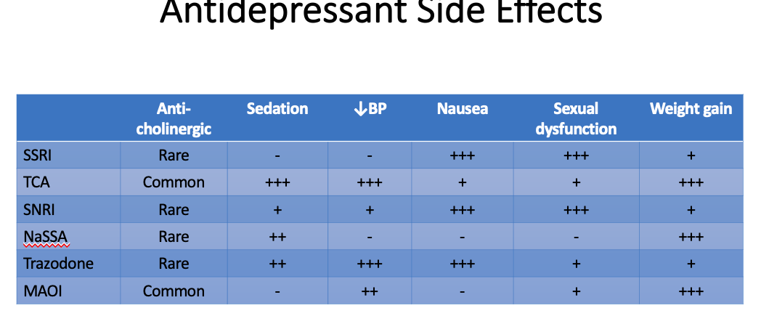  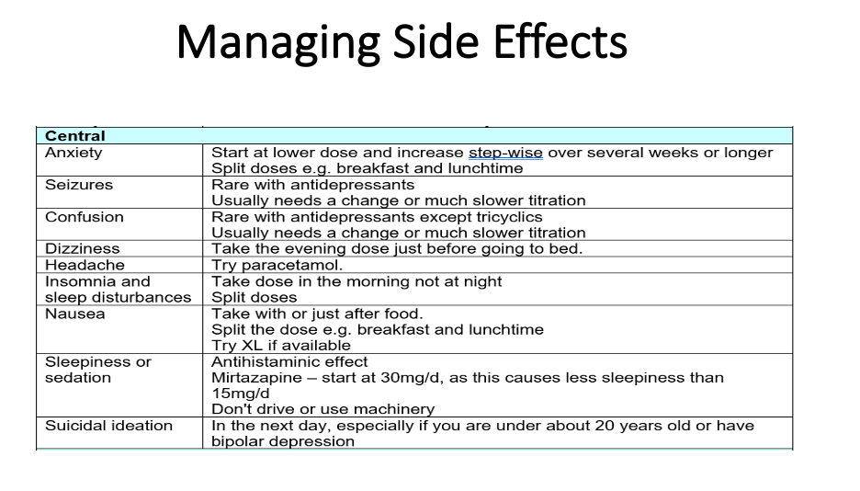  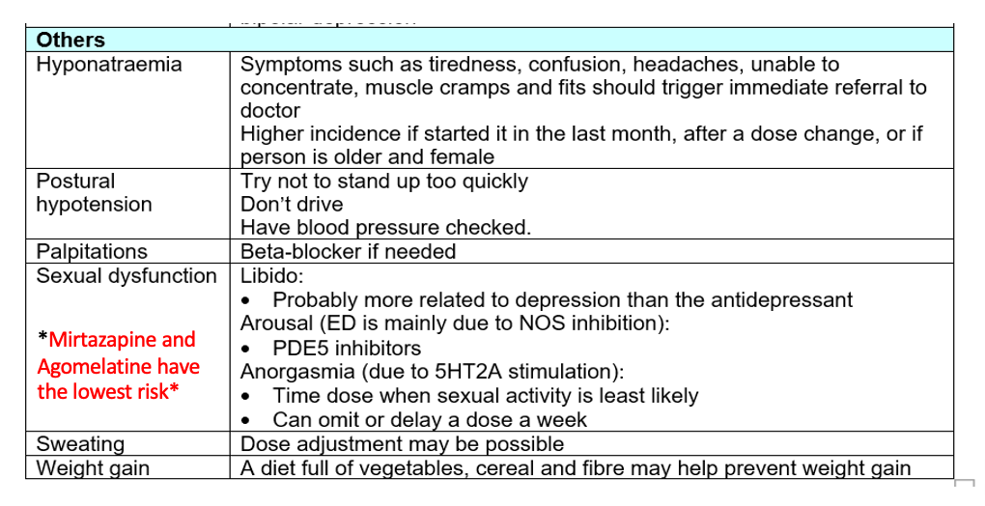  Interactions  Alcohol – may increase sedation. Mirtazapine  Warfarin – SSRIs increase INR  Tamoxifen – paroxetine may inc risk of recurrence of breast cancer  Smoking decreases duloxetine levels  SJW –  Clozapine  1st line - fluoxetine + psychological therapies  2nd line – sertraline or citalopram  Risk of suicide in those under 20  - exclude bipolar depression  - counsel and ensure family is aware  - start low and increase slowly.  Risk of depression usually outweighs risk of using an antidepressant.  Avoid paroxetine  Briggs pregnancy and lactation book  SSRIs better tolerated than TCA’s. may increase risk of bleeds. Start low go slow.  SSRIs generally recommended, may protect against MI. sertraline usually psot mI. Mirtazipine as an alternative  May increase QT interval (ep SSRI and TCA). Citalopram c/I in prolonged QT  ADRs eg postural hypotension, confusion and sedation may increase. Start low go slow. None presferred to another. Greater impairment = greater drug accumulation  Greater impairment = greater risk of toicity. Start low go slow, monitor LFTs.

Disease | Treatment
Anxiety disorders  GAD  OCD  Social phobia  Panic disorder  Moderate-severe | 1st line – SSRIs (in all anxiety disorders)  Eg Escitalopram 5mg/d and Paroxetine 5-10mg/d are licenced. Other SSRIs widely used  - take up to 12 weeks for response in anxiety  - initial worsening common. Increase slowly every 2 weeks or as tolerated  Adjuncts: benzos can help initial anxiety and can be ued for a few weeks. ST beta blockers. Low dose antihistamines ST. Antipsychotics ST.  Try 2 types of SSRI, then SNRI, then pregabalin.  Other agents used: benxos, antipsychptics (risperidone, olanzapine, quetiapine, periciazine), Venlafaxine/ duloxetine, TCAs, pregabalin.  Mirtazipine may be used if pt also has depression + sleep issues  Beta blockers eg propranolol for relief of anxiety symtpoms  Non pharmacological interventions  Psychotherapeutic approaches eg counselling, CBT, anxiety management.  Self help eg caffeine avoidance, relaxation techniques, self help groups, lifestyle changes
1st line = High dose SSRI, Clomipramine (TCA)
Eg clomipramine 250-300mg/d, Fluoxetine 60-80mg/d, sertraline 100-200mg/d
- only central serotonin enhancers are effective.
- other antidepressants ineffective.
- max tolerated dose for 3 months,, 1-2 years minimum to prevent relapse.

1st line – SSRI eg Escitalopram, venlafaxine
Alcohol dependence + social phobia: ST benzodiazepine

Self-help + CBT
1st line – SSRI eg escitalopram, sertraline, citalopram, paroxetine. Or venlafaxine
2nd line – Imipramine or Clomipramine if SSRI c/I or no improvement after 12 weeks
Eating disorders  Anorexia Nervosa  Bulimia Nervosa  Binge eating |  | No pharmacological treatment recommended by NICE  Psychological interventions eg CBT, family therapy  Anxiety associated with anorexia: Antipsychotics, benzos, antihistamines  Enteral feeding/ TPM for those severely emaciated  Other management  - promote good oral hygiene – rinse mouth after vomiting, avoid brushing teeth  - vitaminse and minerals  - osteoperosis  - GI symptoms  - Electrolytes + refeeding syndrome.  - Inc risk of QT prolongtation due to electrolyte abnormalities.  Management of refeeding syndrome  Potentially fatal shifts in fluids + electrolytes when malnourished patients are receiving artificial refeeding  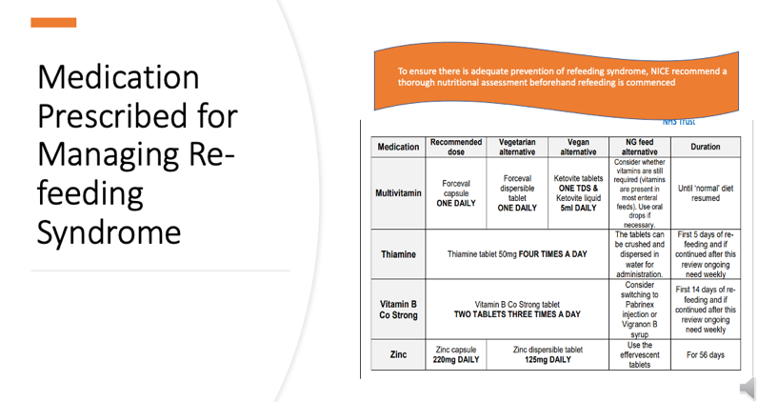  1st line – self help, CBT  2nd line – antidepressants. Fluoxetine 60mh licenced.  1st line – CBT  Alternative/ additional – Trial of SSRI (unliscneced)
Bipolar disorder |  | 1st line = psychological therapies  - CBT, psychotherapy, family therapy.  Treatment depends on presentation and diagnosis  Mania  Patient should be given non-specific calming medications eg benzos, antipsychotics  Then specific mood-stabilisers/ relapse prevention agent as long-term therapy.  1st line agents: Lithium, valproate, olanzapine, quetiapine, aripirazole  2nd line agents: carbamazepine, risperidone, asenapine haloperidol, benzos  - hypnotics/ sedatives considered as sleep deprivation an worsen a manic episode  - tackle co-morbid substance misuse  - stabilise other medical conditions  - discontinue any manicogenic agents eg antidepressants, stimulants.  Combinations usually used as monotherapy not v effective in bipolar  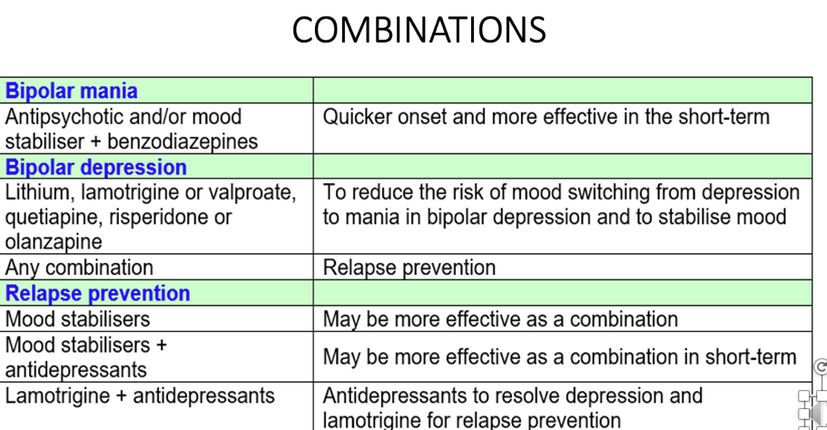  Bipolar depression  Acute  1st line – Lithium, Quetiapine, Olanzapine (UL)  2nd line – Carbamazepine, lurasidone (u/l), antidepressants (u/l)
Personality disorders  Borderline personality disorder |  | No recommended pharmacological therapy  Treat co morbid conditions as appropriate. May include:  - substance misuse, anxiety disorders, affective disorderes (depression, bipolar), eating disorders  - hypertension, CVD, GI disease, arthritis, STDs  In crisis – ST sedatives eg antihistamine (promethazine) no longer than a week. Lowest effective dose
Liver disease  Management of drug induced liver disease  Paracetamol hepatotoxicity  Acute alcohol withdrawal  Cholestatic pruritis  Ascites  Wernicke’s-korsakoff syndrome  Hepatic encephalopathy  Portal hypertension  Bleeding oesophageal varisces  Clotting abnormalities |  | Important to consider dosing as liver disease can increase bioavailability of drugs, causing normal doses to have a toxic effect.  Liver structurally modifies molecules to make them less polar + lipid soluble to aid excretion.  Withdraw drugs and use antidote where approproiate  Pt may need corticosteroids.  <1hr – activated charcoal to remove all unabsorbed  <8hrs – acetyl cysteine to replenish glutathione stores, effective up 24hrs  Methionine  Treatment of liver diseases depends on type. So acute diagnosis is important.  + lifestyle modifications eg alcohol, weight  Symptomatic care + prevent progression  Benzodiazepines to control psychomotor agitation + prevent more severity  Eg chlordiazepoxide 10-50mg QDS, oxazepam (short life benzos)  Seiziures: IV lorazepam.  IV fluids  Nutritional supplementation  Frequent clinical assessment  Don’t send home with supply, resp depression on overdose.  Itchiness due to deposition of bile salts under the skin  Treat underlying cause  1st line – cholestyramine  Antihistamines  Calamine lotion/ methol in aqueous cream.  1st line – spironolactone, aldosterone antagonist  Add on: furosemide if no weight loss.  Bed rest  Na+ and fluid restrict  Too rapid weight loss can cause hypovolaemia, increased risk of encephalopathy.  Fluid can be drained physically  Caused by thiamine deficiency  2 x pabrinex ampoules TDS for 3-5 days  Infuse over 30 mins  Long term oral thiamine 100mg TDS  For 3-6 months post-abstinence  Caused by ammonia + nitrogenous waste bypassing liver + entering BBB  1st line = High dose lactulose 30-50mL TDS  Ionises nitrogenous compounds, reducing absorption  2nd line = rifaximin if lactulose not working.  3rd line = phosphate enemas.  1st line – low dose propranolol  Monitor due to 1st pass metabolism.  Add on – vasodilators eg nitrates if not effective  Heart vessels have thin walls that may rupture  1st line – resuscitation + correction of hypovolameia  Endoscopy to work out wher bleeding has gone  Control bleeding eg sclerotherapy, ligation, balloon tampanade  Can lead to anaemia, bleeding + bruising.  PT >18 secs  1st line – Phytomenadoine (vit k) IV
Renal disease  Acute kidney failure  Chronic kidney failure  Acidosis  Hyperphosphataemia  Hypocalcaemia  Anaemia  Cramps  Restless legs  Vitamins |  | Metformin c/I  1st line Identify + treat underlying cause – eg infection, hypovolaemia, hypotension, nephrotoxic drugs  Temporary dialysis may be needed  Occasionally loop diuretics: eg furosemide 1-2g  In intensive care : Low dose Dopamine 2mcg/kg/min  Antibiotics if caused by infection  Correct electrolytes  Conservative treatment and renal replacement therapy  Hypertension – most drugs are ok. Loop diuretics, cardioselective b blockers, amlodipine, ACEi/ ARB  Targets same as usual  Hyperkalaemia – inc k+  1st line – calcium gluconate injection 10mL 10% over 5-10 mins  To prevent cardiac arrest  2nd line – Insulin 20IU + glucose 50mL 50% IV  Increases k+ uptake by cells  3rd line – Calcium resonium 15-30g powder PO  Binds to k+ in gi tract, releases ca2+. Give lactulose with every dose  Excess H+  Sodium bicarbonate 500-600mg TDS  Cannot excrete phosphate  Give phosphate binder eg aluminium hydroxide  Cacitriol  Or alfacalcidol – just needs hydroxylating at 25 position.  Recombinant human erythropoietin iv/sc  Eg Eprex, neo-recormon, Aranesp  Iron therapy if ferritin levels are low  Eg iron sucrose  Usually at night/ during dialysis  Qunine sulphate 300mg ON/ 30 min before dialysis  Clonazepam 0.5-1mg  Relaxes muscles + hypnotic  Renavit

