3

1. Answer **ALL** parts (a) to (d).

PHA-6020Y Version 2

You have a new patient RG, admitted to the cardiology ward. Their medical notes, blood test results and drug chart are as follows:

**Patient:**

**Hospital number:**

**DoB:**

**Gender:**

**Address:**

**PC:**

**HPC:**

**PMH:**

**DH:**

**SH: Alcohol**

**Smoking Status**

RG

058796

13.04.1971

M

25 Silver Road, Flatplace

Chest pain

Woke up at 3am with crushing chest pain – called 999

Epilepsy (focal) since childhood Hypertension (2 years)

Carbamazepine MR 400mg bd Lamotrigine 100mg bd Amlodipine 5mg od

Atorvastatin 20mg on NKDA

Operations manager, agricultural company 10-15 units/week

Ex-smoker – quit 2 years ago

**OE** BP 145/95 Temp 36.8oC

Pulse 80bpm (regular) Weight 79kg

**Investigations:**

**Diagnosis:**

**Plan:**

ECG: ST-elevation Troponin I 4860ng/mL

STEMI

PPCI completed – DES to RCA

**Dr Nair Bleep 5893**

*Question 1 continues…*

4

*…question 1 continued.*

PHA-6020Y Version 2

Their blood test results on admission are as follows:

Norfolk and Norwich University Hospital NHS Trust

**PATHOLOGY DEPARTMENT** Patient Name: RG

Consultant/GP: Dr T Tse

NHS No: 24386791

PATIENT LOCATION ***Cardiac Ward***

Hosp no: 058796 Sex: M Patient Address: 25 Silver Road, Flatplace Lab Episode No: 8904

Age: 51 Yr Pathology

Date/Time Collection: Today

Address for Report: Flatplace Hospital, Flatplace **BIOCHEMISTRY** **Trop I** **Total chol** **Bilirubin** CollectionLAB No

Today 8904 **4,860\*** 4.8 17 <0.4

ng/ml mmol/L (3-20) µmol/l

**ALT** **GGT** **Na**

**ALP** **AST**

35 32

(20-100) IU/l (5-40) IU/l

**K** **eGFR**

27 41

(5-30) (5-45) IU/l IU/l

**Urea** **Creatinine**

138

(134-145) mmol/L

4.7

(3.6-5.0) mmol/L

>90

ml/min/m 2

5.1

(1.7-7.1) mmol/L

118

(55-125) µmol/L

*Question 1 continues…*

5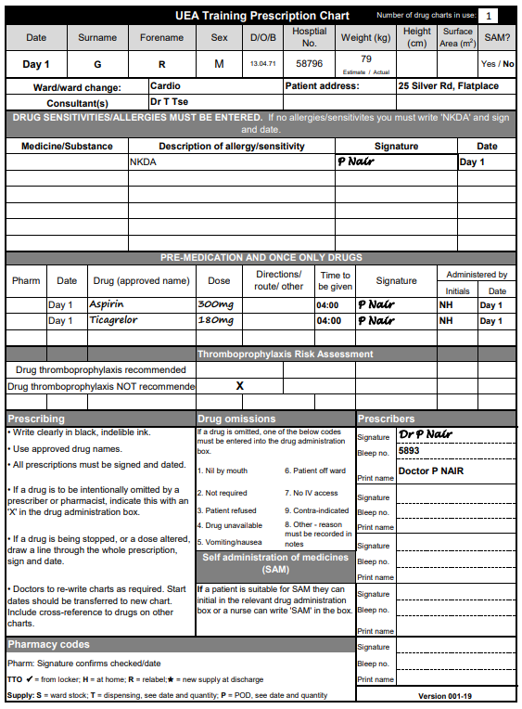

*…question 1 continued.*

PHA-6020Y Version 2

*Question 1 continues…*

6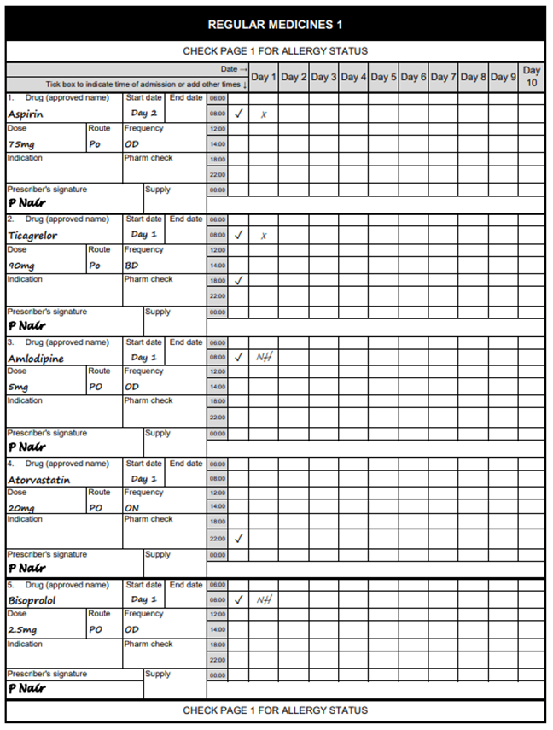

*…question 1 continued.*

PHA-6020Y Version 2

*Question 1 continues…*

7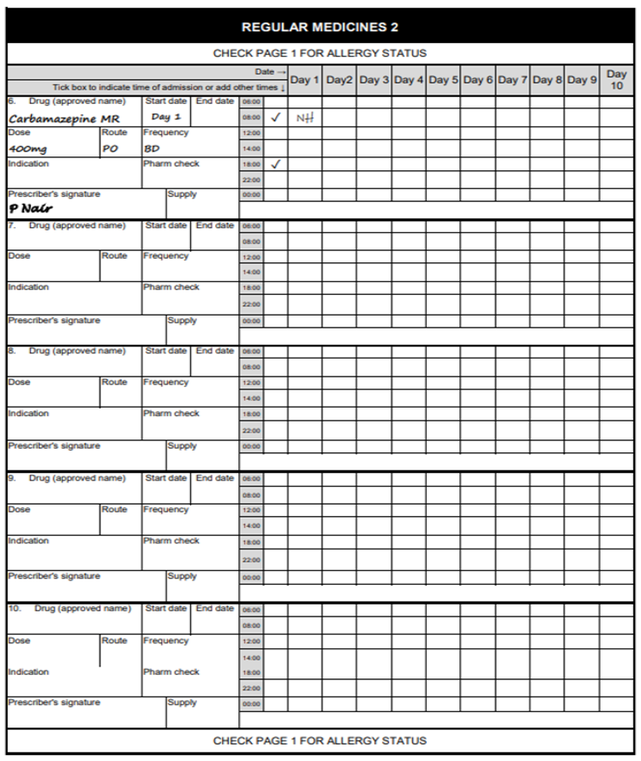

*…question 1 continued.*

PHA-6020Y Version 2

*Question 1 continues…*

8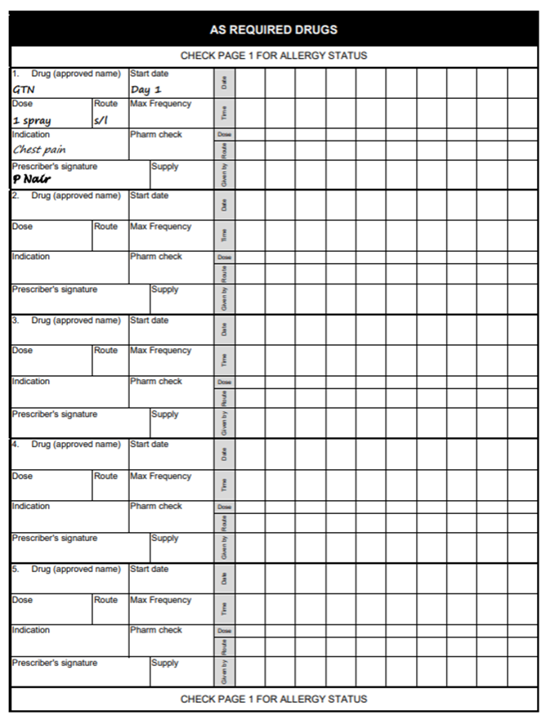

*…question 1 continued.*

PHA-6020Y Version 2

*Question 1 continues…*

1. With reference to current evidence-based guidelines where appropriate, critique RG’s current drug therapy. Describe and explain any interventions or recommendations you would like to make regarding their treatment.

**Acute STEMI Management:**

The patient has been appropriately managed according to current **NICE** and **ESC guidelines** for the treatment of STEMI:

* **Aspirin and Ticagrelor:**
  + Aspirin 300 mg loading dose and 75 mg OD maintenance dose is standard therapy to inhibit platelet aggregation.
  + Ticagrelor 180 mg loading dose and 90 mg BD maintenance dose is recommended as dual antiplatelet therapy (DAPT) alongside aspirin for up to 12 months post-STEMI. Ticagrelor is preferred over clopidogrel due to its superior efficacy in reducing cardiovascular events, as evidenced by the PLATO trial.
* **Bisoprolol 2.5 mg OD:**
  + Initiation of a beta-blocker, such as bisoprolol, is appropriate in STEMI management to reduce myocardial oxygen demand, control heart rate, and decrease the risk of arrhythmias. The dose of 2.5 mg OD is a standard starting dose, but titration should be based on tolerance, heart rate, and blood pressure.
* **GTN Spray:**
  + Glyceryl trinitrate (GTN) spray is appropriate for symptom relief of angina. It is a standard as-needed medication in acute coronary syndrome (ACS) for its vasodilatory effects.

**Recommendation:**

* **Continue current therapy** as per guidelines but monitor blood pressure and heart rate closely. Consider titrating bisoprolol to a higher dose if the patient tolerates it, aiming for a target heart rate of 50-60 bpm, which has been associated with improved outcomes post-MI. Ace inhibitor is used in the secondary prevention for STEMI so it should be added and the amlodipine should be discontinued to assess the patients levels and responsiveness to adding an ace inhibitor before stepping up the treatment and adding in a CCB if the patient blood pressure is still not controlled
* **Ticagrelor severely interacts with Carbamazepine so according to the nice guidelines offer them prasugrel**

**High troponin levels is a biomarker for myocardial infarction so it shows that there is an underlying cause which is the STEMI so appropriate treatment has commenced for it which was the PPCI**